**Experiment: 1 Date: 20-12-24**

**Build mobile application based on the concept activity life cycle with Custom Toast.**

**AIM:** To build mobile application based on the concept activity life cycle with Custom Toast.

**EXPERIMENTAL REQUIREMENTS:** PC with Android Studio and Internet connection

**THEORY:**

Android applications consist of activities, which serve as the primary components of user interaction. Each activity goes through different states in its lifecycle, managed by the Android system. The **Activity Lifecycle** defines the transitions between these states, ensuring efficient resource management.

An Android activity follows a **lifecycle** from the moment it is created to when it is destroyed. The Android system calls specific methods at different points in the activity's lifecycle, allowing developers to manage resources efficiently.

**Key Lifecycle Methods:**

1. **onCreate()** – Called when the activity is first created. Used for initializing UI components and logic.
2. **onStart()** – Called when the activity becomes visible but is not yet interactive.
3. **onResume()** – Called when the activity is in the foreground and ready for user interaction.
4. **onPause()** – Called when the activity is partially obscured (e.g., a dialog appears).
5. **onStop()** – Called when the activity is no longer visible. Used for releasing resources.
6. **onRestart()** – Called when an activity is restarted after being stopped.
7. **onDestroy()** – Called before the activity is completely removed from memory.

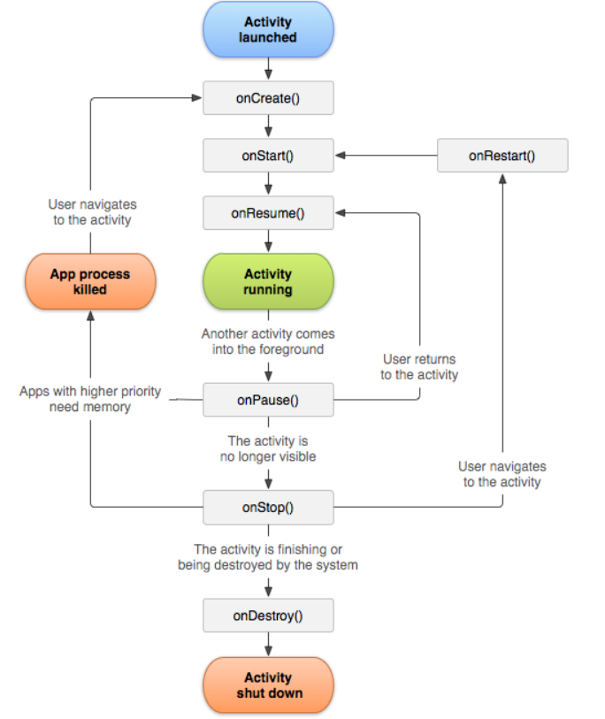

**Toast in Android**

A **Toast** is a small, temporary message that appears at the bottom of the screen and disappears automatically after a short duration. It is used to display brief notifications without interrupting the user experience.

**Types of Toasts in Android:**

1. **Default Toast:**
   * Simple message display using Toast.makeText(context, "Message", Toast.LENGTH_SHORT).show();
2. **Custom Toast:**
   * Uses a custom layout, allowing for images, colors, and text styling.

A **Custom Toast** provides a more visually appealing notification compared to a default Toast. It allows developers to use XML layouts to define the appearance of the toast message.

**Components of a Custom Toast:**

1. **Custom Layout (XML):**
   * A separate XML file is created with TextView, ImageView, or other UI elements.
2. **Inflation in Java Code:**
   * The layout is inflated dynamically using LayoutInflater.
3. **Displaying the Custom Toast:**
   * The custom view is set using Toast.setView() and shown using Toast.show().

**PROCEDURE:**

1. Open Android Studio and start a new project.

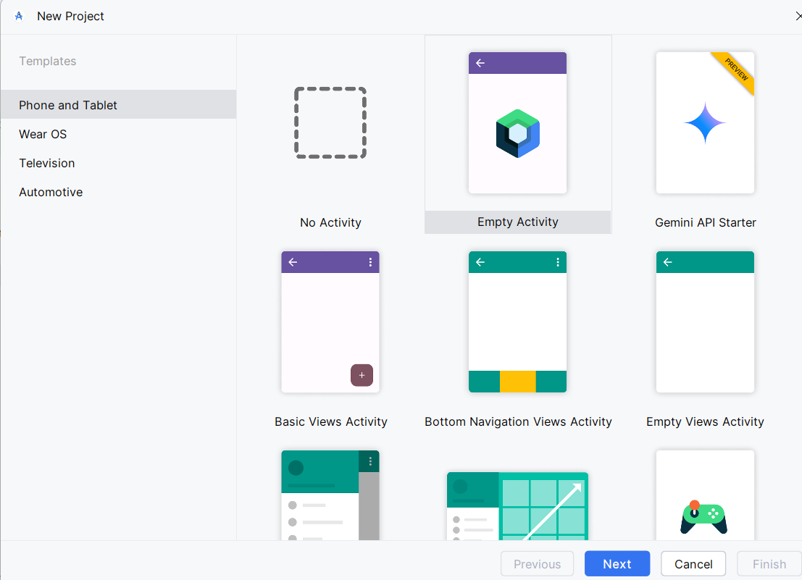

1. Select "No Views Activity" and click Next.

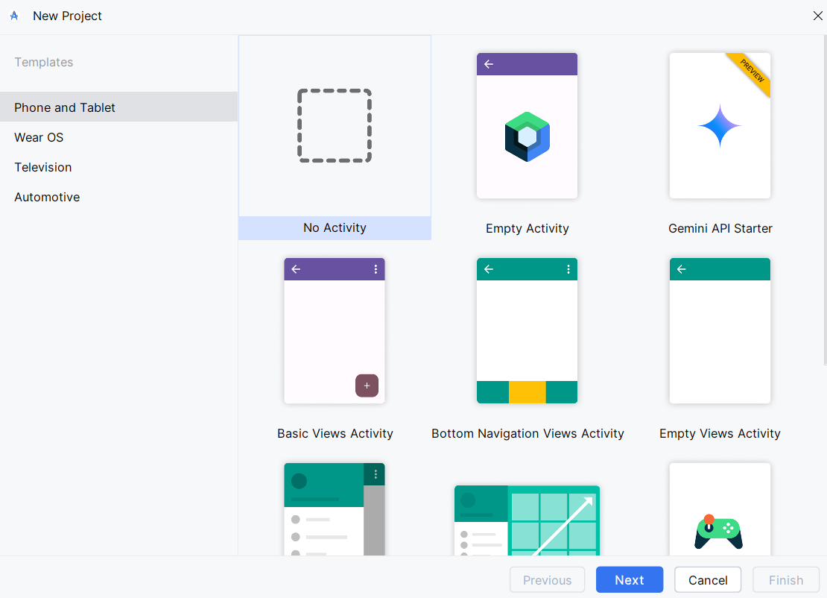

1. Enter project details (Name: ToastApp, Language: Java) and click Finish.

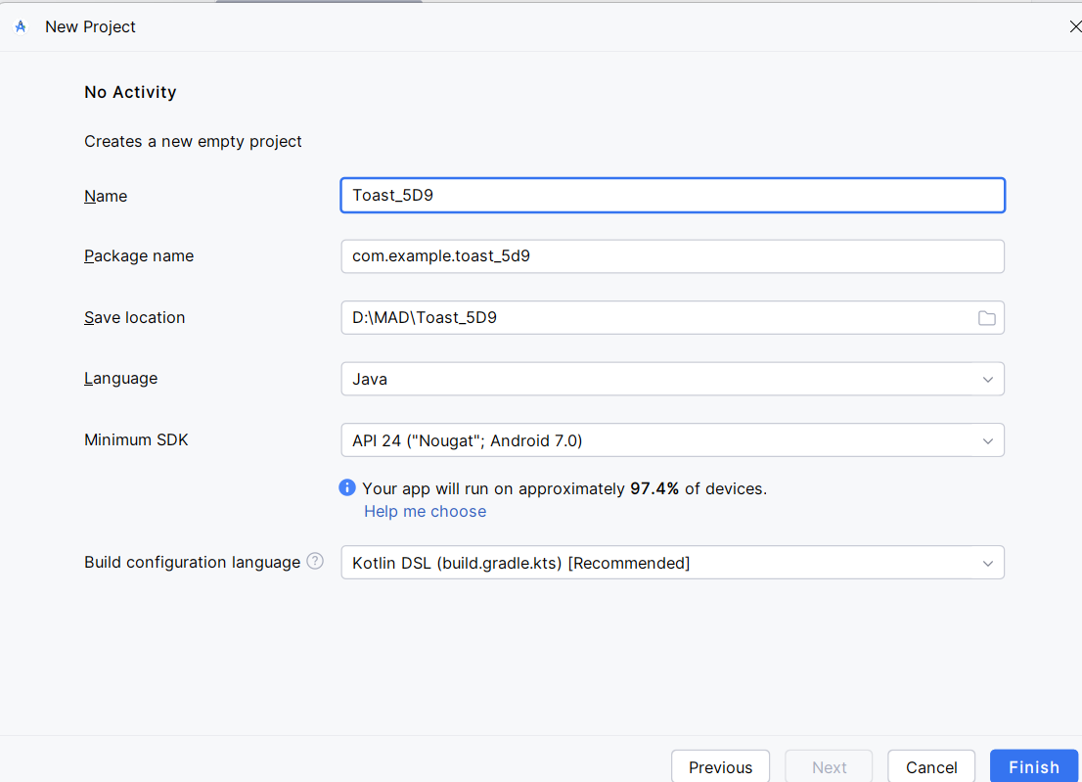

1. To create a new activity, right-click on App > New > Activity > Empty Views Activity, name it MainActivity, check the Launcher Activity option, and click Finish.

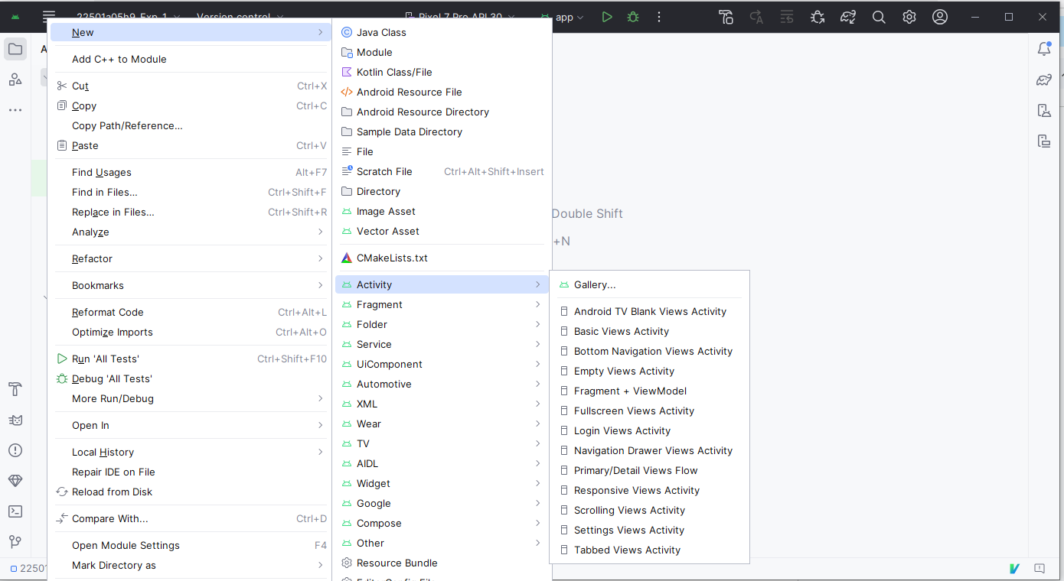

1. Write code in MainActivity.java to implement lifecycle methods and display Custom Toast.
2. To create a new layout file, right-click on App > New > XML > Layout XML file, name it custom_toast_layout, and click Finish.

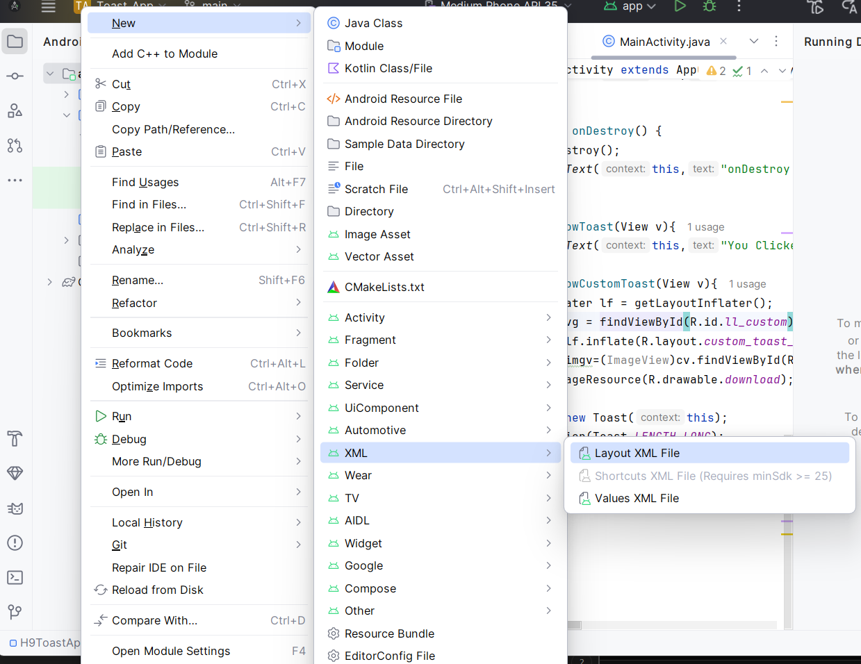

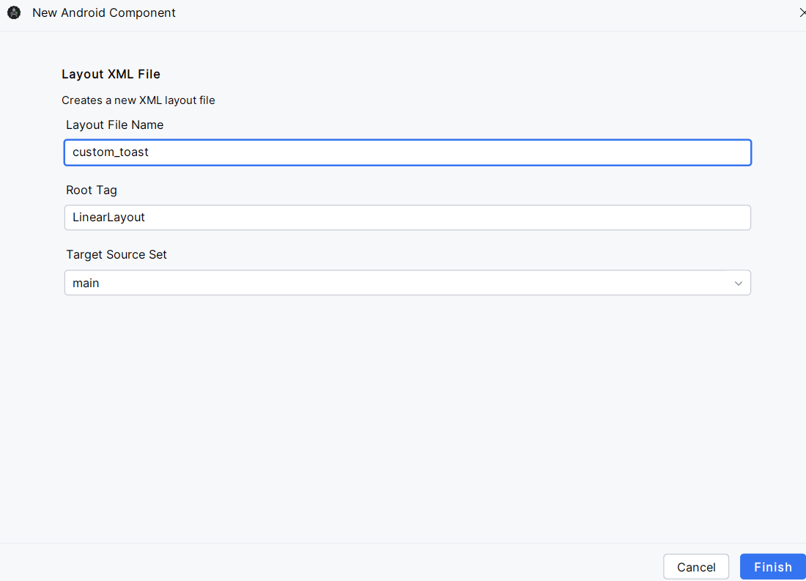

1. To create an Android Virtual Device (AVD) for testing.
   1. In Android Studio, Click **Device Manager** → Click **"+" (Create Device)**.
   2. Select a **mobile model**, choose a **system image**, configure settings, and click **Finish**.
   3. Click **Play** to launch the emulator.

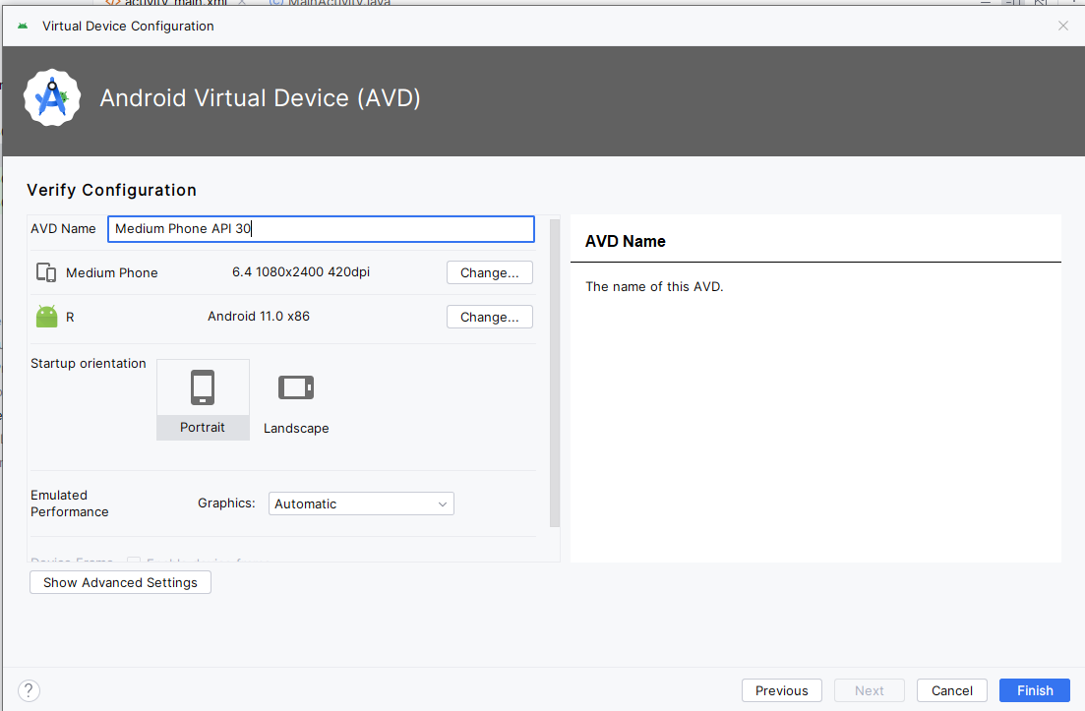

1. Run the application using the emulator.
2. Observe Custom Toast messages appearing at each lifecycle stage.

**PROGRAMS:**

**MainActivity.java**

import android.os.Bundle;  
import android.view.LayoutInflater;  
import android.view.View;  
import android.view.ViewGroup;  
import android.widget.ImageView;  
import android.widget.TextView;  
import android.widget.Toast;  
  
import androidx.activity.EdgeToEdge;  
import androidx.appcompat.app.AppCompatActivity;  
import androidx.core.graphics.Insets;  
import androidx.core.view.ViewCompat;  
import androidx.core.view.WindowInsetsCompat;  
  
public class MainActivity extends AppCompatActivity {  
 @Override  
 protected void onCreate(Bundle savedInstanceState) {  
 super.onCreate(savedInstanceState);  
 EdgeToEdge.enable(this);  
 setContentView(R.layout.activity_main);  
 ViewCompat.setOnApplyWindowInsetsListener(findViewById(R.id.main), (v, insets) -> {  
 Insets systemBars = insets.getInsets(WindowInsetsCompat.Type.systemBars());  
 v.setPadding(systemBars.left, systemBars.top, systemBars.right, systemBars.bottom);  
 return insets;  
 });  
 }  
 public void showToast(View v){  
 Toast.makeText(this, "Harsha Vardhan", Toast.*LENGTH_LONG*).show();  
 }  
 @Override  
 protected void onStart(){  
 super.onStart();  
 Toast.makeText(this,"On start called",Toast.*LENGTH_LONG*).show();  
 }  
 @Override  
 protected void onRestart(){  
 super.onRestart();  
 Toast.makeText(this, "On Restart called", Toast.*LENGTH_SHORT*).show();  
 }  
 @Override  
 protected void onPause(){  
 super.onPause();  
 Toast.makeText(this,"on Pause called",Toast.*LENGTH_LONG*).show();  
 }  
 @Override  
 protected void onResume(){  
 super.onResume();  
 Toast.makeText(this,"on Resume called",Toast.*LENGTH_LONG*).show();  
 }  
 @Override  
 protected void onStop() {  
 super.onStop();  
 Toast.makeText(getApplicationContext(), "onStop Called", Toast.*LENGTH_LONG*).show();  
 }  
  
 public void showCustomToast(View v){  
 LayoutInflater lf=getLayoutInflater();  
 ViewGroup vg=findViewById(R.id.ll_ctoast);  
 View cv=lf.inflate(R.layout.custom_toast_layout,vg);  
 ImageView imgv=cv.findViewById(R.id.imageView);  
 imgv.setImageResource(R.drawable.spidy);  
 TextView tv=cv.findViewById(R.id.textView);  
 tv.setText("SpiderMan");  
  
 Toast t=new Toast(this);  
 t.setDuration(Toast.*LENGTH_LONG*);  
 t.setView(cv);  
 t.show();  
 }  
}

**activity_main.xml**

<?xml version="1.0" encoding="utf-8"?>  
<androidx.constraintlayout.widget.ConstraintLayout xmlns:android="http://schemas.android.com/apk/res/android"  
 xmlns:app="http://schemas.android.com/apk/res-auto"  
 xmlns:tools="http://schemas.android.com/tools"  
 android:id="@+id/main"  
 android:layout_width="match_parent"  
 android:layout_height="match_parent"  
 tools:context=".MainActivity">  
  
 <Button  
 android:id="@+id/button"  
 android:layout_width="wrap_content"  
 android:layout_height="wrap_content"  
 android:layout_marginStart="72dp"  
 android:layout_marginTop="132dp"  
 android:onClick="showToast"  
 android:text="CLICK OVER HERE"  
 android:textSize="24sp"  
 android:textStyle="bold"  
 app:layout_constraintStart_toStartOf="parent"  
 app:layout_constraintTop_toTopOf="parent" />  
  
 <Button  
 android:id="@+id/button2"  
 android:layout_width="wrap_content"  
 android:layout_height="wrap_content"  
 android:layout_marginTop="104dp"  
 android:onClick="showCustomToast"  
 android:text="SHOW CUSTOM TOAST"  
 android:textSize="24sp"  
 app:layout_constraintBottom_toBottomOf="parent"  
 app:layout_constraintEnd_toEndOf="parent"  
 app:layout_constraintHorizontal_bias="0.494"  
 app:layout_constraintStart_toStartOf="parent"  
 app:layout_constraintTop_toBottomOf="@+id/button"  
 app:layout_constraintVertical_bias="0.0" />  
  
</androidx.constraintlayout.widget.ConstraintLayout>

**Custom_toast_layout.xml**

<?xml version="1.0" encoding="utf-8"?>  
<LinearLayout xmlns:android="http://schemas.android.com/apk/res/android"  
 xmlns:app="http://schemas.android.com/apk/res-auto"  
 xmlns:tools="http://schemas.android.com/tools"  
 android:id="@+id/ll_ctoast"  
 android:layout_width="match_parent"  
 android:layout_height="match_parent">  
  
 <ImageView  
 android:id="@+id/imageView"  
 android:layout_width="wrap_content"  
 android:layout_height="wrap_content"  
 android:layout_weight="1"  
 tools:srcCompat="@tools:sample/avatars" />  
  
 <TextView  
 android:id="@+id/textView"  
 android:layout_width="wrap_content"  
 android:layout_height="wrap_content"  
 android:layout_weight="1"  
 android:text="TextView" />  
</LinearLayout>

**OUTPUT:**

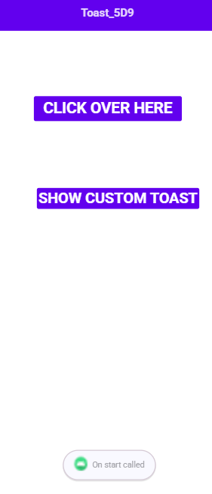 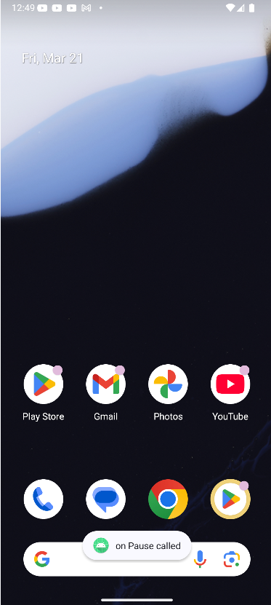 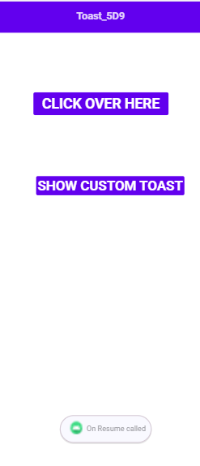

When device is running When app is closed When app is opened again

onStart() is evoked onPause() is evoked onResume() is evoked

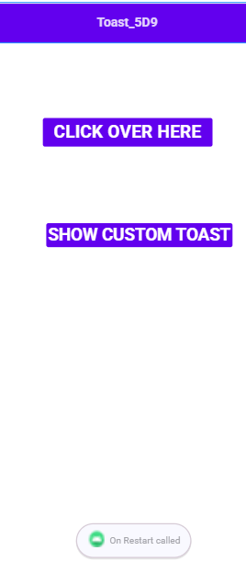 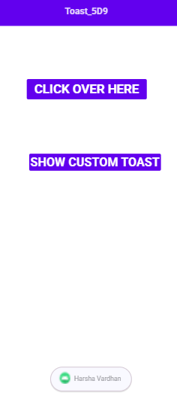 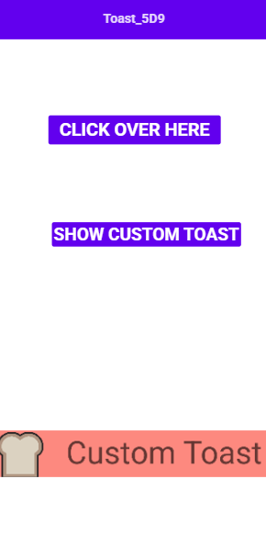

When emulator is switch on When Toast is clicked When CUSTOM_TOAST is clicked

onRestart() is evoked showToast() is evoked showcustom_toast() is evoked

**RESULT:** Mobile application based on the concept activity life cycle with Custom Toast built successfully.

**Experiment: 2 Date:27-12-24**

**Build mobile application using different layouts**

**AIM:** To build mobile application using different layouts.

**EXPERIMENTAL REQUIREMENTS:** PC with Android Studio and Internet connection

**THEORY:**

Mobile applications require well-structured user interfaces (UI) to provide a seamless experience. In Android development, layouts define how UI components are arranged on the screen. Choosing the right layout ensures efficiency, readability, and responsiveness.

A **layout** in Android is a container that organizes UI elements such as buttons, text views, and images. Android provides multiple layouts, each designed for specific use cases. The commonly used layouts include:

**a) Linear Layout**

* Arranges UI components in a single direction, either **vertically** or **horizontally**.
* Ensures a simple and sequential arrangement of elements.
* Suitable for lists, forms, or stacked elements.
* Requires careful management of screen space as each element takes up its own row or column.

**b) Relative Layout**

* Positions UI components relative to each other or to the parent container.
* Allows flexibility in arranging elements without a fixed order.
* Reduces nesting of layouts, making UI design more efficient.
* Ideal for placing components dynamically based on screen size and content.

**c) Table Layout**

* Organizes UI components in a grid-like structure using rows and columns.
* Useful for displaying structured data such as tables, forms, and schedules.
* Each row can contain multiple UI elements, and columns are automatically adjusted based on content.
* Best for applications requiring a tabular representation of information.

**d) Frame Layout**

* Designed to hold a single child view, though multiple views can be layered.
* Used for displaying overlapping elements, such as images, videos, or floating buttons.
* Helps in creating UI elements that require stacking, like media players or pop-up dialogs.
* Simple and efficient for cases where only one view is needed at a time.

**e) Tab Layout**

* Provides a tab-based navigation system, allowing users to switch between different sections.
* Enhances the user experience by organizing content into multiple views accessible through tabs.
* Often used with navigation components such as ViewPager or fragments to handle different screens.
* Ideal for applications that require categorized navigation, like social media apps, shopping apps, or settings menus.

**PROCEDURE:**

1. Open Android Studio and create a new project.
2. Select Empty Activity, enter project details, and click Finish.
3. Create a main activity, as the Launcher Activity.
4. Open res/layout/activity_main.xml and choose a layout type (LinearLayout, RelativeLayout, TableLayout, FrameLayout, or TabLayout).
5. Use Intents in MainActivity.java to navigate between activities.
6. Click Run to test the application on an emulator or device.

**PROGRAMS:**

**MainActivity.java**

package com.example.layout;  
  
import android.content.Intent;  
import android.os.Bundle;  
import android.view.View;  
  
import androidx.activity.EdgeToEdge;  
import androidx.appcompat.app.AppCompatActivity;  
import androidx.core.graphics.Insets;  
import androidx.core.view.ViewCompat;  
import androidx.core.view.WindowInsetsCompat;  
  
public class MainActivity extends AppCompatActivity {  
  
 @Override  
 protected void onCreate(Bundle savedInstanceState) {  
 super.onCreate(savedInstanceState);  
 EdgeToEdge.*enable*(this);  
 setContentView(R.layout.*activity_main*);  
 ViewCompat.*setOnApplyWindowInsetsListener*(findViewById(R.id.*main*), (v, insets) -> {  
 Insets systemBars = insets.getInsets(WindowInsetsCompat.Type.*systemBars*());  
 v.setPadding(systemBars.left, systemBars.top, systemBars.right, systemBars.bottom);  
 return insets;  
 });  
 }  
  
 public void show_ll_activity(View v){  
 Intent i = new Intent(this, LinearLayoutActivity.class);  
 this.startActivity(i);  
 }  
  
 public void show_tl_activity(View v){  
 Intent i = new Intent(this, TableLayoutActivity.class);  
 this.startActivity(i);  
 }  
  
 public void show_fl_activity(View v){  
 Intent i = new Intent(this, FrameLayoutActivity.class);  
 this.startActivity(i);  
 }  
  
 public void show_rl_activity(View v){  
 Intent i = new Intent(this, RelativeLayoutActivity.class);  
 this.startActivity(i);  
 }  
  
 public void show_tabl_activity(View v){  
 Intent i = new Intent(this, TabLayoutActivity.class);  
 this.startActivity(i);  
 }  
}

**activity_main.xml**

*<?*xml version="1.0" encoding="utf-8"*?>*<androidx.constraintlayout.widget.ConstraintLayout xmlns:android="http://schemas.android.com/apk/res/android"  
 xmlns:app="http://schemas.android.com/apk/res-auto"  
 xmlns:tools="http://schemas.android.com/tools"  
 android:id="@+id/main"  
 android:layout_width="match_parent"  
 android:layout_height="match_parent"  
 tools:context=".MainActivity">  
  
 <Button  
 android:id="@+id/btn_linear"  
 android:layout_width="wrap_content"  
 android:layout_height="wrap_content"  
 android:layout_marginTop="160dp"  
 android:onClick="show_ll_activity"  
 android:text="Linear Layout"  
 app:layout_constraintEnd_toEndOf="parent"  
 app:layout_constraintHorizontal_bias="0.498"  
 app:layout_constraintStart_toStartOf="parent"  
 app:layout_constraintTop_toTopOf="parent" />  
  
 <Button  
 android:id="@+id/btn_table"  
 android:layout_width="wrap_content"  
 android:layout_height="wrap_content"  
 android:layout_marginTop="60dp"  
 android:onClick="show_tl_activity"  
 android:text="Table Layout"  
 app:layout_constraintEnd_toEndOf="parent"  
 app:layout_constraintHorizontal_bias="0.511"  
 app:layout_constraintStart_toStartOf="parent"  
 app:layout_constraintTop_toBottomOf="@+id/btn_linear" />  
  
 <Button  
 android:id="@+id/btn_frame"  
 android:layout_width="wrap_content"  
 android:layout_height="wrap_content"  
 android:layout_marginTop="68dp"  
 android:onClick="show_fl_activity"  
 android:text="Frame Layout"  
 app:layout_constraintEnd_toEndOf="parent"  
 app:layout_constraintHorizontal_bias="0.498"  
 app:layout_constraintStart_toStartOf="parent"  
 app:layout_constraintTop_toBottomOf="@+id/btn_table" />  
  
 <Button  
 android:id="@+id/btn_relative"  
 android:layout_width="wrap_content"  
 android:layout_height="wrap_content"  
 android:layout_marginTop="64dp"  
 android:onClick="show_rl_activity"  
 android:text="Relative Layout"  
 app:layout_constraintEnd_toEndOf="parent"  
 app:layout_constraintHorizontal_bias="0.498"  
 app:layout_constraintStart_toStartOf="parent"  
 app:layout_constraintTop_toBottomOf="@+id/btn_frame" />  
  
 <Button  
 android:id="@+id/btn_tablayout"  
 android:layout_width="wrap_content"  
 android:layout_height="wrap_content"  
 android:layout_marginTop="36dp"  
 android:onClick="show_tabl_activity"  
 android:text="Tab Layout"  
 app:layout_constraintEnd_toEndOf="parent"  
 app:layout_constraintHorizontal_bias="0.498"  
 app:layout_constraintStart_toStartOf="parent"  
 app:layout_constraintTop_toBottomOf="@+id/btn_relative" />  
  
 <TextView  
 android:id="@+id/textView"  
 android:layout_width="wrap_content"  
 android:layout_height="wrap_content"  
 android:layout_marginTop="84dp"  
 android:text="Layout_5D9"  
 android:textSize="24sp"  
 app:layout_constraintBottom_toTopOf="@+id/btn_linear"  
 app:layout_constraintEnd_toEndOf="parent"  
 app:layout_constraintStart_toStartOf="parent"  
 app:layout_constraintTop_toTopOf="parent"  
 app:layout_constraintVertical_bias="0.0" />  
</androidx.constraintlayout.widget.ConstraintLayout>

**LinearLayout.java**

package com.example.layout;  
  
import android.content.Intent;  
import android.os.Bundle;  
import android.view.View;  
import android.widget.LinearLayout;  
  
import androidx.activity.EdgeToEdge;  
import androidx.appcompat.app.AppCompatActivity;  
import androidx.core.graphics.Insets;  
import androidx.core.view.ViewCompat;  
import androidx.core.view.WindowInsetsCompat;  
  
public class LinearLayoutActivity extends AppCompatActivity {  
 private LinearLayout mainLayout;  
  
 @Override  
 protected void onCreate(Bundle savedInstanceState) {  
 super.onCreate(savedInstanceState);  
 EdgeToEdge.*enable*(this);  
 setContentView(R.layout.*activity_linear_layout*);  
  
 mainLayout = findViewById(R.id.*main*);  
  
 ViewCompat.*setOnApplyWindowInsetsListener*(findViewById(R.id.*main*), (v, insets) -> {  
 Insets systemBars = insets.getInsets(WindowInsetsCompat.Type.*systemBars*());  
 v.setPadding(systemBars.left, systemBars.top, systemBars.right, systemBars.bottom);  
 return insets;  
 });  
 }  
  
 public void changeOrientation(View view) {  
 if (mainLayout.getOrientation() == LinearLayout.*VERTICAL*) {  
 mainLayout.setOrientation(LinearLayout.*HORIZONTAL*);  
 } else {  
 mainLayout.setOrientation(LinearLayout.*VERTICAL*);  
 }  
 }  
}

**activity_linear_layout.xml**

*<?*xml version="1.0" encoding="utf-8"*?>*<LinearLayout xmlns:android="http://schemas.android.com/apk/res/android"  
 android:id="@+id/main"  
 android:layout_width="match_parent"  
 android:layout_height="match_parent"  
 android:orientation="vertical"  
 xmlns:tools="http://schemas.android.com/tools"  
 tools:context=".LinearLayoutActivity">  
  
 <Button  
 android:id="@+id/button"  
 android:layout_width="133dp"  
 android:layout_height="91dp"  
 android:onClick="changeOrientation"  
 android:text="CHANGE ORIENTATION"  
 android:textSize="14sp" />  
  
 <ImageView  
 android:id="@+id/imageView"  
 android:layout_width="159dp"  
 android:layout_height="165dp"  
 android:src="@drawable/dog" />  
  
 <ImageView  
 android:id="@+id/imageView2"  
 android:layout_width="125dp"  
 android:layout_height="195dp"  
 android:src="@drawable/flower" />  
</LinearLayout>

**FrameActivity.java**

package com.example.layout;  
  
import android.os.Bundle;  
  
import androidx.activity.EdgeToEdge;  
import androidx.appcompat.app.AppCompatActivity;  
import androidx.core.graphics.Insets;  
import androidx.core.view.ViewCompat;  
import androidx.core.view.WindowInsetsCompat;  
  
public class FrameLayoutActivity extends AppCompatActivity {  
  
 @Override  
 protected void onCreate(Bundle savedInstanceState) {  
 super.onCreate(savedInstanceState);  
 EdgeToEdge.*enable*(this);  
 setContentView(R.layout.*activity_frame_layout*);  
 ViewCompat.*setOnApplyWindowInsetsListener*(findViewById(R.id.*main*), (v, insets) -> {  
 Insets systemBars = insets.getInsets(WindowInsetsCompat.Type.*systemBars*());  
 v.setPadding(systemBars.left, systemBars.top, systemBars.right, systemBars.bottom);  
 return insets;  
 });  
 }  
}

**activity_frame.xml**

*<?*xml version="1.0" encoding="utf-8"*?>*<FrameLayout xmlns:android="http://schemas.android.com/apk/res/android"  
 xmlns:app="http://schemas.android.com/apk/res-auto"  
 xmlns:tools="http://schemas.android.com/tools"  
 android:id="@+id/main"  
 android:layout_width="match_parent"  
 android:layout_height="match_parent"  
 tools:context=".FrameLayoutActivity">  
  
 <Button  
 android:id="@+id/button"  
 android:layout_width="297dp"  
 android:layout_height="102dp"  
 android:layout_margin="50sp"  
 android:text="DOG" />  
  
 <ImageView  
 android:id="@+id/imageView4"  
 android:layout_width="wrap_content"  
 android:layout_height="wrap_content"  
 android:layout_marginLeft="69sp"  
 android:layout_marginTop="250sp"  
 app:srcCompat="@drawable/dog" />  
  
</FrameLayout>

**TablesLayout.java**

package com.example.layout;  
  
import android.os.Bundle;  
import android.widget.ImageView;  
  
import androidx.activity.EdgeToEdge;  
import androidx.appcompat.app.AppCompatActivity;  
import androidx.core.graphics.Insets;  
import androidx.core.view.ViewCompat;  
import androidx.core.view.WindowInsetsCompat;  
  
public class TableLayoutActivity extends AppCompatActivity {  
  
 @Override  
 protected void onCreate(Bundle savedInstanceState) {  
 super.onCreate(savedInstanceState);  
 EdgeToEdge.*enable*(this);  
 setContentView(R.layout.*activity_table_layout*);  
 ViewCompat.*setOnApplyWindowInsetsListener*(findViewById(R.id.*main*), (v, insets) -> {  
 Insets systemBars = insets.getInsets(WindowInsetsCompat.Type.*systemBars*());  
 v.setPadding(systemBars.left, systemBars.top, systemBars.right, systemBars.bottom);  
 return insets;  
 });  
 ImageView imgv1=(ImageView) findViewById(R.id.*img1*);  
 imgv1.setImageResource(R.drawable.*img*);  
 ImageView imgv2=(ImageView) findViewById(R.id.*img2*);  
 imgv2.setImageResource(R.drawable.*lion*);  
 ImageView imgv3=(ImageView) findViewById(R.id.*img3*);  
 imgv3.setImageResource(R.drawable.*flower*);  
 ImageView imgv4=(ImageView) findViewById(R.id.*img4*);  
 imgv4.setImageResource(R.drawable.*dog*);  
  
 }  
}

**activity_tables_layout.xml**

<?xml version="1.0" encoding="utf-8"?>  
<TableLayout xmlns:android="http://schemas.android.com/apk/res/android"  
 xmlns:app="http://schemas.android.com/apk/res-auto"  
 xmlns:tools="http://schemas.android.com/tools"  
 tools:context=".TableLayoutActivity"  
 android:id="@+id/main"  
 android:layout_width="409dp"  
 android:layout_height="729dp"  
 tools:layout_editor_absoluteX="1dp"  
 tools:layout_editor_absoluteY="1dp">  
  
 <TableRow  
 android:layout_width="match_parent"  
 android:layout_height="match_parent">  
  
 <ImageView  
 android:id="@+id/img1"  
 android:layout_width="wrap_content"  
 android:layout_height="wrap_content"  
 android:src="@drawable/img" />  
 </TableRow>  
  
 <TableRow  
 android:layout_width="match_parent"  
 android:layout_height="match_parent">  
  
 <ImageView  
 android:id="@+id/img2"  
 android:layout_width="wrap_content"  
 android:layout_height="wrap_content"  
 android:src="@drawable/lion" />  
 </TableRow>  
  
 <TableRow  
 android:layout_width="match_parent"  
 android:layout_height="match_parent">  
  
 <ImageView  
 android:id="@+id/img3"  
 android:layout_width="wrap_content"  
 android:layout_height="wrap_content"  
 android:src="@drawable/flower" />  
 </TableRow>  
  
 <TableRow  
 android:layout_width="match_parent"  
 android:layout_height="match_parent">  
  
 <ImageView  
 android:id="@+id/img4"  
 android:layout_width="wrap_content"  
 android:layout_height="wrap_content"  
 android:src="@drawable/dog" />  
 </TableRow>  
</TableLayout>

**TabsLayout.java**

package com.example.layout;  
  
import android.os.Bundle;  
  
import androidx.activity.EdgeToEdge;  
import androidx.appcompat.app.AppCompatActivity;  
import androidx.core.graphics.Insets;  
import androidx.core.view.ViewCompat;  
import androidx.core.view.WindowInsetsCompat;  
  
public class TabLayoutActivity extends AppCompatActivity {  
  
 @Override  
 protected void onCreate(Bundle savedInstanceState) {  
 super.onCreate(savedInstanceState);  
 EdgeToEdge.*enable*(this);  
 setContentView(R.layout.*activity_tab_layout*);  
 ViewCompat.*setOnApplyWindowInsetsListener*(findViewById(R.id.*main*), (v, insets) -> {  
 Insets systemBars = insets.getInsets(WindowInsetsCompat.Type.*systemBars*());  
 v.setPadding(systemBars.left, systemBars.top, systemBars.right, systemBars.bottom);  
 return insets;  
 });  
 }  
}

**activity_tabs_layout.xml**

*<?*xml version="1.0" encoding="utf-8"*?>*<androidx.constraintlayout.widget.ConstraintLayout xmlns:android="http://schemas.android.com/apk/res/android"  
 xmlns:app="http://schemas.android.com/apk/res-auto"  
 xmlns:tools="http://schemas.android.com/tools"  
 android:id="@+id/main"  
 android:layout_width="match_parent"  
 android:layout_height="match_parent"  
 tools:context=".TabLayoutActivity">  
  
 <com.google.android.material.tabs.TabLayout  
 android:id="@+id/tab"  
 android:layout_width="409dp"  
 android:layout_height="wrap_content"  
 tools:layout_editor_absoluteX="1dp"  
 tools:layout_editor_absoluteY="10dp"  
 tools:ignore="MissingConstraints">  
  
 <com.google.android.material.tabs.TabItem  
 android:id="@+id/tab_A"  
 android:layout_width="wrap_content"  
 android:layout_height="wrap_content"  
 android:text="@string/A" />  
  
 <com.google.android.material.tabs.TabItem  
 android:id="@+id/tab_B"  
 android:layout_width="wrap_content"  
 android:layout_height="wrap_content"  
 android:text="@string/B" />  
  
 <com.google.android.material.tabs.TabItem  
 android:id="@+id/tab_C"  
 android:layout_width="wrap_content"  
 android:layout_height="wrap_content"  
 android:text="@string/C" />  
 </com.google.android.material.tabs.TabLayout>  
</androidx.constraintlayout.widget.ConstraintLayout>

**RelativeLayout.java**

package com.example.layout;  
  
import android.os.Bundle;  
  
import androidx.activity.EdgeToEdge;  
import androidx.appcompat.app.AppCompatActivity;  
import androidx.core.graphics.Insets;  
import androidx.core.view.ViewCompat;  
import androidx.core.view.WindowInsetsCompat;  
  
public class RelativeLayoutActivity extends AppCompatActivity {  
  
 @Override  
 protected void onCreate(Bundle savedInstanceState) {  
 super.onCreate(savedInstanceState);  
 EdgeToEdge.*enable*(this);  
 setContentView(R.layout.*activity_relative_layout*);  
 ViewCompat.*setOnApplyWindowInsetsListener*(findViewById(R.id.*main*), (v, insets) -> {  
 Insets systemBars = insets.getInsets(WindowInsetsCompat.Type.*systemBars*());  
 v.setPadding(systemBars.left, systemBars.top, systemBars.right, systemBars.bottom);  
 return insets;  
 });  
 }  
}

**activity_relatives_layout.xml**

<?xml version="1.0" encoding="utf-8"?>  
<RelativeLayout xmlns:android="http://schemas.android.com/apk/res/android"  
 xmlns:app="http://schemas.android.com/apk/res-auto"  
 xmlns:tools="http://schemas.android.com/tools"  
 android:id="@+id/main"  
 android:layout_width="match_parent"  
 android:layout_height="match_parent"  
 tools:context=".RelativeLayoutActivity">  
  
 <TextView  
 android:id="@+id/txt_title"  
 android:layout_width="wrap_content"  
 android:layout_height="226dp"  
 android:layout_alignParentStart="true"  
 android:layout_alignParentEnd="true"  
 android:layout_marginStart="48dp"  
 android:layout_marginTop="50dp"  
 android:layout_marginEnd="65dp"  
 android:fontFamily="casual"  
 android:text="Appilication From"  
 android:textSize="25sp"  
 android:textStyle="bold" />  
  
 <TextView  
 android:id="@+id/text_name1"  
 android:layout_width="wrap_content"  
 android:layout_height="wrap_content"  
 android:layout_alignBottom="@id/txt_title"  
 android:layout_marginLeft="60dp"  
 android:layout_marginBottom="135dp"  
 android:text="name" />  
  
 <EditText  
 android:id="@+id/edittext1"  
 android:layout_width="139dp"  
 android:layout_height="wrap_content"  
 android:layout_alignStart="@+id/txt_title"  
 android:layout_alignEnd="@+id/txt_title"  
 android:layout_alignBottom="@+id/txt_title"  
 android:layout_marginStart="74dp"  
 android:layout_marginEnd="85dp"  
 android:layout_marginBottom="127dp"  
 android:ems="10"  
 android:inputType="text"  
 android:layoutDirection="inherit"  
 android:minHeight="48dp"  
 android:text="Name" />  
  
 <TextView  
 android:id="@+id/text_name2"  
 android:layout_width="wrap_content"  
 android:layout_height="wrap_content"  
 android:layout_alignParentStart="true"  
 android:layout_alignParentEnd="true"  
 android:layout_alignParentBottom="true"  
 android:layout_marginStart="57dp"  
 android:layout_marginEnd="296dp"  
 android:layout_marginBottom="532dp"  
 android:text="Roll No" />  
  
 <EditText  
 android:id="@+id/edittext2"  
 android:layout_width="127dp"  
 android:layout_height="wrap_content"  
 android:layout_alignParentStart="true"  
 android:layout_alignParentEnd="true"  
 android:layout_alignParentBottom="true"  
 android:layout_marginStart="123dp"  
 android:layout_marginEnd="160dp"  
 android:layout_marginBottom="527dp"  
 android:ems="10"  
 android:inputType="text"  
 android:minHeight="48dp"  
 android:text="Roll No" />  
  
 <Button  
 android:id="@+id/button2"  
 android:layout_width="wrap_content"  
 android:layout_height="wrap_content"  
 android:layout_alignParentStart="true"  
 android:layout_alignParentEnd="true"  
 android:layout_alignParentBottom="true"  
 android:layout_marginStart="136dp"  
 android:layout_marginEnd="181dp"  
 android:layout_marginBottom="441dp"  
 android:text="Button" />  
  
</RelativeLayout>

**OUTPUT:**

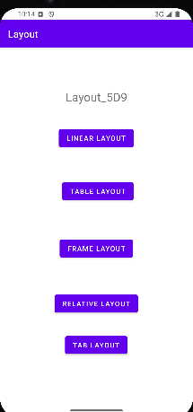 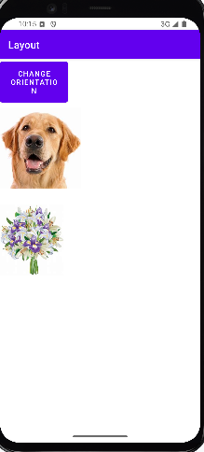 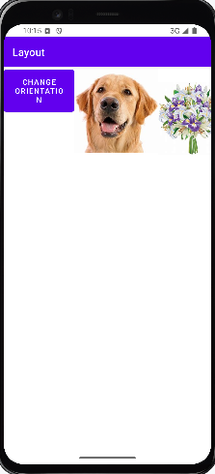

Main Activity Linear layout in Linear layout in

horizontal orientation vertical orientation

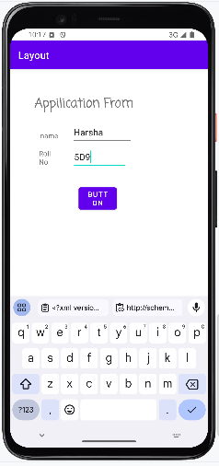 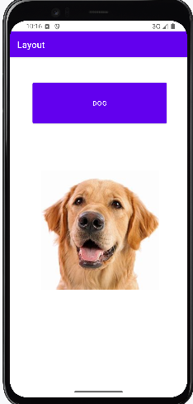 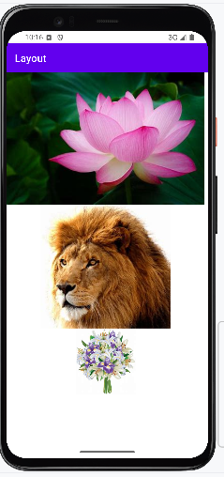

Relative Layout Frame Layout Table Layout

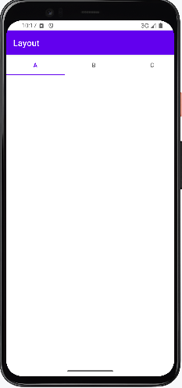

Tab Layout

**RESULT:** Mobile application using different layouts is built successfully.

**Experiment: 3 Date:10-1-2025**

**Build mobile application using different dialogs**

**AIM:** To build mobile application using different dialogs.

**EXPERIMENTAL REQUIREMENTS:** PC with Android Studio and Internet connection

**THEORY:**

A **dialog** is a small window that prompts the user to make a decision or enter additional information. A dialog doesn't fill the screen and is normally used for modal events that require users to take an action before they can proceed. The commonly used dialogs include:

**a) Alert Dialog**

* Android AlertDialog can be used to display the dialog message with OK and Cancel buttons.
* It can be used to interrupt and ask the user about his/her choice to continue or discontinue.
* This Dialog maximum 3 buttons allowed.

**b) DatePicker Dialog**

* Android DatePickerDialog puts a DatePicker on a Dialog.
* It allows user to select Date(day,month and year) in our application.

**c) TimePicker Dialog**

* Android TimePicker is a component that permits users to select a time including hour and minute.
* Android Time Picker allows you to select the time of day in either 24 hour or AM/PM mode.
* The time consists of hours, minutes and clock format or spinner format.
* Android provides this functionality through TimePicker class.

**d) Custom Dialog**

* Custom dialog is used to customize a dialog of your needs.
* You can create your own custom dialog with custom characteristics.

**PROCEDURE:**

1. Open Android Studio and create a new project.
2. Select Empty Activity, enter project details, and click Finish.
3. Create a main activity, as the Launcher Activity.
4. In main activity, create 3 buttons to access Alert dialog, time picker dialog and date picker dialog.
5. After writing the necessary code, click Run to test the application on an emulator or device.

**PROGRAMS:**

**MainActivity.java**

package com.example.dialog_5d9;  
  
import android.app.AlertDialog;  
import android.app.DatePickerDialog;  
import android.app.TimePickerDialog;  
import android.content.DialogInterface;  
import android.os.Bundle;  
import android.view.View;  
import android.widget.DatePicker;  
import android.widget.TimePicker;  
import android.widget.Toast;  
  
import androidx.activity.EdgeToEdge;  
import androidx.appcompat.app.AppCompatActivity;  
import androidx.core.graphics.Insets;  
import androidx.core.view.ViewCompat;  
import androidx.core.view.WindowInsetsCompat;  
  
import java.util.Calendar;  
  
public class MainActivity extends AppCompatActivity {  
  
 @Override  
 protected void onCreate(Bundle savedInstanceState) {  
 super.onCreate(savedInstanceState);  
 EdgeToEdge.*enable*(this);  
 setContentView(R.layout.*activity_main*);  
 ViewCompat.*setOnApplyWindowInsetsListener*(findViewById(R.id.*main*), (v, insets) -> {  
 Insets systemBars = insets.getInsets(WindowInsetsCompat.Type.*systemBars*());  
 v.setPadding(systemBars.left, systemBars.top, systemBars.right, systemBars.bottom);  
 return insets;  
 });  
 }  
  
 public void showDialog(View v) {  
 AlertDialog.Builder adb = new AlertDialog.Builder(this);  
 Toast.*makeText*(this, "Welcome", Toast.*LENGTH_SHORT*).show();  
 adb.setTitle("Harsha Vardhan");  
 adb.setMessage("This is the dialog created by Harsha!!");  
 adb.setPositiveButton("Continue", (dialogInterface, i) ->  
 Toast.*makeText*(MainActivity.this, "Thank You", Toast.*LENGTH_LONG*).show());  
 adb.setNegativeButton("Cancel", (dialogInterface, i) ->  
 Toast.*makeText*(MainActivity.this, "Try Again", Toast.*LENGTH_LONG*).show());  
 AlertDialog ad = adb.create();  
 ad.show();  
 }  
  
 public void showTime(View v) {  
 Calendar c = Calendar.*getInstance*();  
 int dh = c.get(Calendar.*HOUR*);  
 int dm = c.get(Calendar.*MINUTE*);  
 TimePickerDialog tpd = new TimePickerDialog(this, (view, hourOfDay, minute) ->  
 Toast.*makeText*(MainActivity.this, hourOfDay + "H: " + minute + "M", Toast.*LENGTH_LONG*).show(),  
 dh, dm, true);  
 tpd.show();  
 }  
  
 public void showDate(View v) {  
 Calendar c = Calendar.*getInstance*();  
 int dYear = c.get(Calendar.*YEAR*);  
 int dMon = c.get(Calendar.*MONTH*);  
 int dDay = c.get(Calendar.*DAY_OF_MONTH*);  
  
 DatePickerDialog dpd = new DatePickerDialog(this, (datePicker, i, i1, i2) ->  
 Toast.*makeText*(MainActivity.this, i + "Y:" + i1 + "M:" + i2 + "D", Toast.*LENGTH_LONG*).show(),  
 dYear, dMon, dDay);  
 dpd.setTitle("Pick a date please");  
 dpd.show();  
 }  
}

**activity_main.xml**

<?xml version="1.0" encoding="utf-8"?>  
<androidx.constraintlayout.widget.ConstraintLayout xmlns:android="http://schemas.android.com/apk/res/android"  
 xmlns:app="http://schemas.android.com/apk/res-auto"  
 xmlns:tools="http://schemas.android.com/tools"  
 android:id="@+id/main"  
 android:layout_width="match_parent"  
 android:layout_height="match_parent"  
 tools:context=".MainActivity">  
  
 <Button  
 android:id="@+id/button2"  
 android:layout_width="wrap_content"  
 android:layout_height="wrap_content"  
 android:onClick="showDialog"  
 android:text="SHOW DIALOG"  
 app:layout_constraintBottom_toBottomOf="parent"  
 app:layout_constraintEnd_toEndOf="parent"  
 app:layout_constraintHorizontal_bias="0.477"  
 app:layout_constraintStart_toStartOf="parent"  
 app:layout_constraintTop_toTopOf="parent"  
 app:layout_constraintVertical_bias="0.207" />  
  
 <Button  
 android:id="@+id/button5"  
 android:layout_width="wrap_content"  
 android:layout_height="wrap_content"  
 android:layout_marginTop="140dp"  
 android:onClick="showTime"  
 android:text="SHOW TIME"  
 app:layout_constraintEnd_toEndOf="parent"  
 app:layout_constraintHorizontal_bias="0.467"  
 app:layout_constraintStart_toStartOf="parent"  
 app:layout_constraintTop_toBottomOf="@+id/button2" />  
  
 <Button  
 android:id="@+id/button6"  
 android:layout_width="wrap_content"  
 android:layout_height="wrap_content"  
 android:layout_marginTop="132dp"  
 android:onClick="showDate"  
 android:text="SHOW DATE "  
 app:layout_constraintBottom_toBottomOf="parent"  
 app:layout_constraintEnd_toEndOf="parent"  
 app:layout_constraintHorizontal_bias="0.456"  
 app:layout_constraintStart_toStartOf="parent"  
 app:layout_constraintTop_toBottomOf="@+id/button5"  
 app:layout_constraintVertical_bias="0.0" />  
</androidx.constraintlayout.widget.ConstraintLayout>

**OUTPUT:**

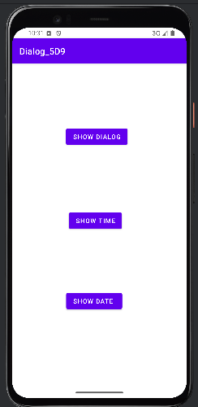 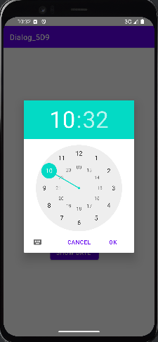 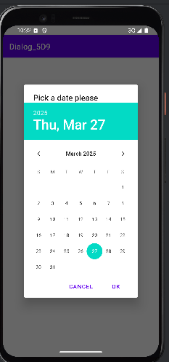

Main Activity TimePicker Dialog DatePicker Dialog

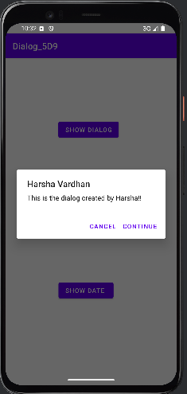

Alert Dialog

**RESULT:** Mobile application using dialogs has been built successfully.

**Experiment: 4 Date: 31-1-2025**

**Build mobile application using Recycler View**

**AIM:** To build mobile application using Recycler View.

**EXPERIMENTAL REQUIREMENTS:** PC with Android Studio and Internet connection

**THEORY:**

In Android, RecyclerView is a powerful and flexible UI component used for displaying large sets of data efficiently by recycling views, making it an improved version of ListView. It works by creating only the necessary number of views that fit on the screen and reusing them as the user scrolls, reducing memory usage and improving performance.

Below are some of the essential components and their functionalities:

**a) RecyclerView.Adapter**

The Adapter acts as a bridge between the data source and the RecyclerView, binding data to each item in the list. It contains three important methods:

* onCreateViewHolder(ViewGroup parent, int viewType) – Creates new ViewHolder instances that hold references to item views.
* onBindViewHolder(ViewHolder holder, int position) – Binds data to the ViewHolder at the specified position.
* getItemCount() – Returns the total number of items in the dataset.

**b) RecyclerView.ViewHolder**

ViewHolder is responsible for holding references to individual item views in RecyclerView, reducing the need to repeatedly find views, thus improving performance.

* It extends the RecyclerView.ViewHolder class and holds UI elements inside each row.
* Helps in reusing views to minimize resource consumption.

**c) RecyclerView.LayoutManager**

LayoutManager defines how items in the RecyclerView should be arranged on the screen. Android provides three built-in LayoutManagers:

* LinearLayoutManager – Displays items in a vertical or horizontal list (like a ListView).
* GridLayoutManager – Displays items in a grid pattern (like a photo gallery).
* StaggeredGridLayoutManager – Displays items in staggered rows or columns, commonly used for Pinterest-like layouts.

**PROCEDURE:**

1. Open Android Studio and create a new project.
2. Select Empty Activity, enter project details, and click Finish.
3. Create a main activity, as the Launcher Activity.
4. Create itemlayout_recyclerview xml file as a relative layout to display the view.
5. Create Department, DepartmentViewHolder, DepartmentAdapter and DAdapter java files.
6. To generate a .java file:
   1. Double click on package
   2. Click on New > Java
   3. Give name to the Java file

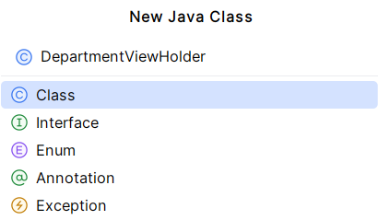

1. After writing the necessary code, click Run to test the application on an emulator or device.

**PROGRAMS:**

**MainActivity.java**

package com.example.recycler;  
  
import androidx.appcompat.app.AppCompatActivity;  
import androidx.recyclerview.widget.LinearLayoutManager;  
import androidx.recyclerview.widget.RecyclerView;  
  
import android.os.Bundle;  
  
import com.example.recycler.Department;  
import com.example.recycler.DepartmentAdaptor;  
import com.example.recycler.R;  
  
import java.util.ArrayList;  
import java.util.List;  
  
public class MainActivity extends AppCompatActivity {  
 RecyclerView rcv;  
 @Override  
 protected void onCreate(Bundle savedInstanceState) {  
 super.onCreate(savedInstanceState);  
 setContentView(R.layout.activity_main);  
 List<Department> depts = new ArrayList<>();  
 depts.add(new Department(R.drawable.cse, "CSE", "210"));  
 depts.add(new Department(R.drawable.ece, "ECE", "140"));  
 depts.add(new Department(R.drawable.eee, "EEE", "70"));  
 rcv = (RecyclerView) this.findViewById(R.id.rcv);  
 rcv.setAdapter(new DepartmentAdaptor(getApplicationContext(), depts));  
 rcv.setLayoutManager(new LinearLayoutManager(getApplicationContext()));  
 }  
}

**activity_main.xml**

<?xml version="1.0" encoding="utf-8"?>  
<FrameLayout xmlns:android="http://schemas.android.com/apk/res/android"  
 xmlns:app="http://schemas.android.com/apk/res-auto"  
 xmlns:tools="http://schemas.android.com/tools"  
 android:layout_width="match_parent"  
 android:layout_height="match_parent"  
 tools:context=".MainActivity">  
  
 <androidx.recyclerview.widget.RecyclerView  
 android:id="@+id/rcv"  
 android:layout_width="match_parent"  
 android:layout_height="match_parent"  
 tools:layout_editor_absoluteX="1dp"  
 tools:layout_editor_absoluteY="1dp" />  
</FrameLayout>

**itemlayout_recyclerview.xml**

<?xml version="1.0" encoding="utf-8"?>  
<RelativeLayout xmlns:android="http://schemas.android.com/apk/res/android"  
 xmlns:app="http://schemas.android.com/apk/res-auto"  
 xmlns:tools="http://schemas.android.com/tools"  
 android:layout_width="wrap_content"  
 android:layout_height="wrap_content">  
  
 <ImageView  
 android:id="@+id/imgv_dpic"  
 android:layout_width="120dp"  
 android:layout_height="120dp"  
 android:layout_margin="10dp"  
 tools:srcCompat="@tools:sample/avatars" />  
  
 <TextView  
 android:id="@+id/txtv_dname"  
 android:layout_width="match_parent"  
 android:layout_height="wrap_content"  
 android:layout_above="@+id/txtv_dseats"  
 android:layout_marginLeft="8dp"  
 android:layout_marginBottom="3dp"  
 android:layout_toRightOf="@id/imgv_dpic"  
 android:text="Dept name"  
 android:textSize="24sp" />  
  
 <TextView  
 android:id="@+id/txtv_dseats"  
 android:layout_width="wrap_content"  
 android:layout_height="wrap_content"  
 android:layout_alignBottom="@id/imgv_dpic"  
 android:layout_marginLeft="13dp"  
 android:layout_marginBottom="18dp"  
 android:layout_toRightOf="@id/imgv_dpic"  
 android:text="seats"  
 android:textSize="24sp" />  
</RelativeLayout>

**Department.java**

package com.example.recycler;  
  
public class Department {  
 int dpic;  
 String dname;  
 String dseats;  
  
 public Department(int dpic, String dname, String dseats) {  
 this.dpic = dpic;  
 this.dname = dname;  
 this.dseats = dseats;  
 }  
  
 public int getDpic() {  
 return dpic;  
 }  
  
 public String getDname() {  
 return dname;  
 }  
  
 public String getDseats() {  
 return dseats;  
 }  
  
 public void setDpic(int dpic) {  
 this.dpic = dpic;  
 }  
  
 public void setDseats(String dseats) {  
 this.dseats = dseats;  
 }  
  
 public void setDname(String dname) {  
 this.dname = dname;  
 }  
}

**DepartmentAdapter.java**

package com.example.recycler;  
  
import android.content.Context;  
import android.view.LayoutInflater;  
import android.view.ViewGroup;  
  
import androidx.annotation.NonNull;  
import androidx.recyclerview.widget.RecyclerView;  
  
import java.util.List;  
  
public class DepartmnetAdaptor extends RecyclerView.Adapter<DepartmentViewHolder> {  
  
 Context ct;  
 List<Department> depts;  
  
 public DepartmnetAdaptor(Context ct, List<Department> depts) {  
 this.ct = ct;  
 this.depts = depts;  
 }  
  
 @NonNull  
 @Override  
 public DepartmentViewHolder onCreateViewHolder(@NonNull ViewGroup parent, int viewType) {  
 return new DepartmentViewHolder(LayoutInflater.*from*(ct).inflate(R.layout.*itemlayout_recyclerview*, parent, false));  
 }  
  
 @Override  
 public void onBindViewHolder(@NonNull DepartmentViewHolder holder, int position) {  
 holder.dpic.setImageResource(depts.get(position).getDpic());  
 holder.dname.setText(depts.get(position).getDname());  
 holder.dseats.setText(depts.get(position).getDseats());  
 }  
  
 @Override  
 public int getItemCount() {  
 return depts.size();  
 }  
}

**DepartmentViewHolder.java**

package com.example.recycler;  
  
import android.view.View;  
import android.widget.ImageView;  
import android.widget.TextView;  
  
import androidx.annotation.NonNull;  
import androidx.recyclerview.widget.RecyclerView;  
  
public class DepartmentViewHolder extends RecyclerView.ViewHolder {  
 ImageView dpic;  
 TextView dname,dseats;  
  
 public DepartmentViewHolder(@NonNull View itemView) {  
 super(itemView);  
 dpic=(ImageView) itemView.findViewById(R.id.imgv_dpic);  
 dname=(TextView) itemView.findViewById(R.id.txtv_dname);  
 dseats=(TextView) itemView.findViewById(R.id.txtv_dseats);  
 }  
  
}

**OUTPUT:**

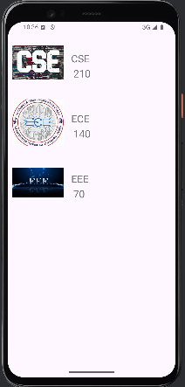

Main Activity

**RESULT:** Mobile application using Recycler View has been built successfully.

**Experiment: 5 Date:** 7-02-2025

**Build mobile application to switch from one activity to another using Intent.**

**AIM:** To build mobile application to switch from one activity to another using Intent.

**EXPERIMENTAL REQUIREMENTS:** PC with Android Studio and Internet connection

**THEORY:**

In Android, Intents are a powerful messaging system that allows components within an application—or even across different applications—to communicate and perform actions. Intents enable developers to navigate between activities, start services, broadcast messages, or request actions from other apps, such as opening a web page or sharing content.

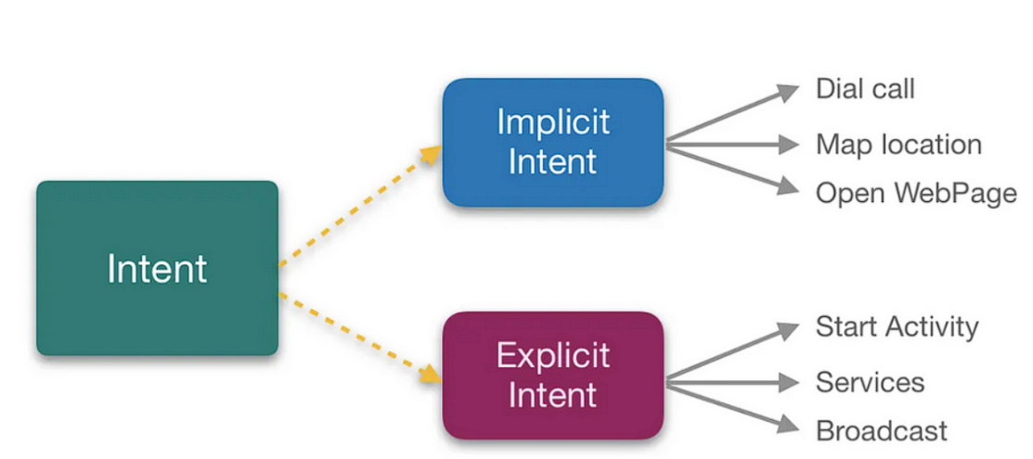There are two main types of intents: explicit intents and implicit intents. Explicit intents are used when the target component is known, such as launching a specific activity within the same app. For example, an explicit intent can be used to move from a login screen to a home screen. On the other hand, implicit intents do not specify a particular component but declare an action, allowing the system to determine which app can handle it. A common example of an implicit intent is opening a URL in a web browser or sharing an image via different apps. Intents also allow passing data between components using extras, making them essential for seamless interaction within Android applications.

**PROCEDURE:**

1. Open Android Studio and start a new project.
2. Select "No Views Activity" and click Next.
3. Enter project details (Name: SwitchIntent, Language: Java) and click Finish.
4. To create a new activity, right-click on App > New > Activity > Empty Views Activity, name it MainActivity, check the Launcher Activity option, and click Finish.
5. Write code in MainActivity.java to implement intent.
6. To create a new layout file, right-click on App > New > XML > Layout XML file, name it, and click Finish.
7. Run the application using the emulator.

**PROGRAMS:**

**MainActivity.java**

package com.example.a22501a05g7_exp5;  
import android.content.Intent;  
import android.net.Uri;  
import android.os.Bundle;  
import android.util.Log;  
import android.view.View;  
import android.widget.Button;  
import android.widget.EditText;  
import android.widget.Toast;  
import androidx.activity.EdgeToEdge;  
import androidx.appcompat.app.AppCompatActivity;  
import androidx.core.graphics.Insets;  
import androidx.core.view.ViewCompat;  
import androidx.core.view.WindowInsetsCompat;  
import com.example.a22501a05g7_exp5.R;  
import com.example.a22501a05g7_exp5.SecondActivity;  
public class MainActivity extends AppCompatActivity {  
 @Override  
 protected void onCreate(Bundle savedInstanceState) {  
 super.onCreate(savedInstanceState);  
 setContentView(R.layout.*activity_main*);  
 }  
 public void Show_second(View v) {  
 Intent i = new Intent(this, SecondActivity.class);  
 startActivity(i);  
 }  
 public void send_email(View v) {  
 Intent emailIntent = new Intent(Intent.*ACTION_SEND*);  
 emailIntent.setData(Uri.*parse*("mailto:"));  
 emailIntent.setType("text/plain");  
 emailIntent.putExtra(Intent.*EXTRA_EMAIL*, new String[]{""});  
 emailIntent.putExtra(Intent.*EXTRA_CC*, new String[]{""});  
 emailIntent.putExtra(Intent.*EXTRA_SUBJECT*, "Your subject");  
 emailIntent.putExtra(Intent.*EXTRA_TEXT*, "Email message goes here");  
  
 try {  
 startActivity(Intent.*createChooser*(emailIntent, "Send mail..."));  
 finish();  
 Log.*i*("Finished sending email.", "");  
 } catch (android.content.ActivityNotFoundException ex) {  
 Toast.*makeText*(MainActivity.this, "There is no email client installed.", Toast.*LENGTH_SHORT*).show();  
 }  
 }  
}

**activity_main.xml**

*<?*xml version="1.0" encoding="utf-8"*?>*<androidx.constraintlayout.widget.ConstraintLayout xmlns:android="http://schemas.android.com/apk/res/android"  
 xmlns:app="http://schemas.android.com/apk/res-auto"  
 xmlns:tools="http://schemas.android.com/tools"  
 android:id="@+id/main"  
 android:layout_width="match_parent"  
 android:layout_height="match_parent"  
 tools:context=".MainActivity">  
  
 <Button  
 android:id="@+id/SwitchToActivity"  
 android:layout_width="wrap_content"  
 android:layout_height="wrap_content"  
 android:onClick="Show_second"  
 android:text="Show Second Activity"  
 app:layout_constraintBottom_toTopOf="@+id/button2"  
 app:layout_constraintEnd_toEndOf="parent"  
 app:layout_constraintHorizontal_bias="0.46"  
 app:layout_constraintStart_toStartOf="parent"  
 app:layout_constraintTop_toTopOf="parent"  
 app:layout_constraintVertical_bias="0.557" />  
  
 <Button  
 android:id="@+id/button2"  
 android:layout_width="wrap_content"  
 android:layout_height="wrap_content"  
 android:layout_marginBottom="448dp"  
 android:onClick="send_email"  
 android:text="SEND EMIAL"  
 app:layout_constraintBottom_toBottomOf="parent"  
 app:layout_constraintEnd_toEndOf="parent"  
 app:layout_constraintHorizontal_bias="0.46"  
 app:layout_constraintStart_toStartOf="parent" />  
</androidx.constraintlayout.widget.ConstraintLayout>

**SecondActivity.java**

package com.example.a22501a05g7_exp5;  
import android.content.Intent;  
import android.os.Bundle;  
import android.view.View;  
import androidx.activity.EdgeToEdge;  
import androidx.appcompat.app.AppCompatActivity;  
import androidx.core.graphics.Insets;  
import androidx.core.view.ViewCompat;  
import androidx.core.view.WindowInsetsCompat;  
public class SecondActivity extends AppCompatActivity {  
 @Override  
 protected void onCreate(Bundle savedInstanceState) {  
 super.onCreate(savedInstanceState);  
 EdgeToEdge.*enable*(this);  
 setContentView(R.layout.*activity_second*);  
 ViewCompat.*setOnApplyWindowInsetsListener*(findViewById(R.id.*main*), (v, insets) -> {  
 Insets systemBars = insets.getInsets(WindowInsetsCompat.Type.*systemBars*());  
 v.setPadding(systemBars.left, systemBars.top, systemBars.right, systemBars.bottom);  
 return insets;  
 });  
 }  
 public void show_main(View v){  
 Intent i=new Intent(this,MainActivity.class);  
 startActivity(i);  
 }  
}

**activity_second.xml**

*<?*xml version="1.0" encoding="utf-8"*?>*<androidx.constraintlayout.widget.ConstraintLayout xmlns:android="http://schemas.android.com/apk/res/android"  
 xmlns:app="http://schemas.android.com/apk/res-auto"  
 xmlns:tools="http://schemas.android.com/tools"  
 android:id="@+id/main"  
 android:layout_width="match_parent"  
 android:layout_height="match_parent"  
 tools:context=".SecondActivity">  
  
 <Button  
 android:id="@+id/button3"  
 android:layout_width="wrap_content"  
 android:layout_height="wrap_content"  
 android:onClick="show_main"  
 android:text="REDIRECT TO MAIN ACTIVITY"  
 app:layout_constraintBottom_toBottomOf="parent"  
 app:layout_constraintEnd_toEndOf="parent"  
 app:layout_constraintStart_toStartOf="parent"  
 app:layout_constraintTop_toTopOf="parent" />  
</androidx.constraintlayout.widget.ConstraintLayout>

**OUTPUT:**

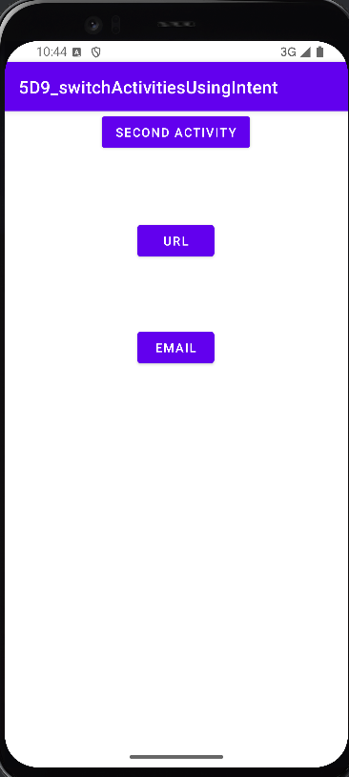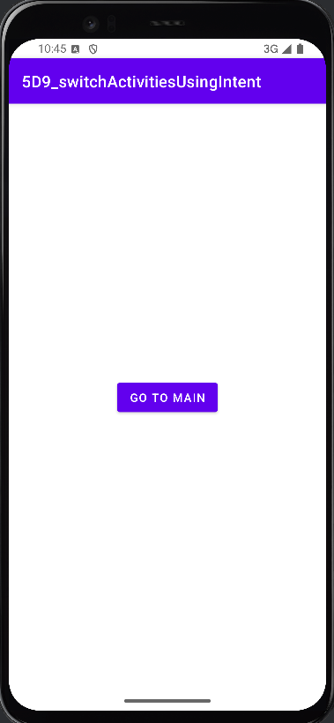

Main Activity Show second activity clicked when we clicked on URL

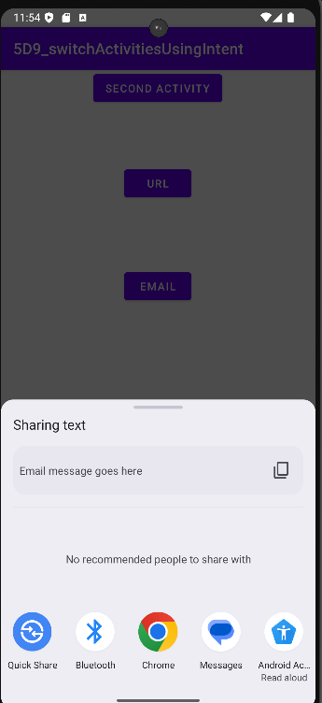

When send Email is clicked

**RESULT:** Mobile application to switch from one activity to another using Intent is built successfully.

**Experiment: 6 Date: 14-02-2025**

**Build mobile application to demonstrate Dynamic Fragments**

**AIM:** To Build mobile application to demonstrate Dynamic Fragments

**EXPERIMENTAL REQUIREMENTS:** PC with Android Studio and Internet connection

**THEORY:**

**Fragments in Android**

A Fragment represents a reusable portion of an app's UI. It defines and manages its own layout, has its own lifecycle, and can handle its own input events. However, fragments cannot exist independently—they must be hosted by an Activity or another fragment. The fragment’s view hierarchy attaches to the host’s view hierarchy.

**Benefits of Using Fragments**

1. **Modular UI Design:** Dividing UI into fragments makes it easier to manage and modify the activity's appearance at runtime.
2. **Better UI Adaptability:** Fragments are ideal for creating UIs that can change dynamically, such as adapting to different screen sizes or orientations.
3. **Improved Code Organization:** Using fragments keeps the UI code more organized, making it easier to maintain and scale.

**Activity vs. Fragment**

* **Activity**: The best place to manage global UI elements, such as a **navigation drawer**.
* **Fragment**: Best suited for defining and managing the UI of a single screen or a portion of a screen.

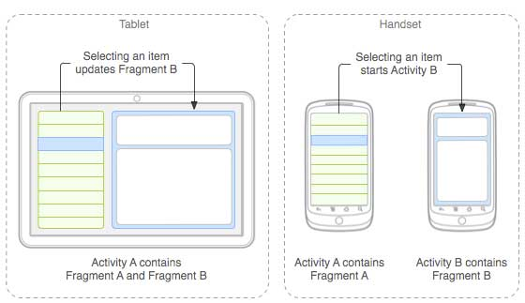

**PROCEDURE:**

1. Open Android Studio and start a new project.
2. Select "No Views Activity" and click Next.
3. Enter project details and click Finish.
4. To create a new activity, right-click on App > New > Activity > Empty Views Activity, name it MainActivity, check the Launcher Activity option, and click Finish.
5. Write code in MainActivity.java to implement intent.
6. To create fragments, right-click on App > New > Fragment > Blank Fragment, name it, and click Finish.

1. Run the application using the emulator.

**PROGRAMS:**

**MainActivity.java**

package com.example.a22501a05g7_exp6;  
import android.os.Bundle;  
import androidx.activity.EdgeToEdge;  
import androidx.annotation.NonNull;  
import androidx.appcompat.app.AppCompatActivity;  
import androidx.core.graphics.Insets;  
import androidx.core.view.ViewCompat;  
import androidx.core.view.WindowInsetsCompat;  
import androidx.fragment.app.FragmentManager;  
import androidx.fragment.app.FragmentResultListener;  
import androidx.fragment.app.FragmentTransaction;  
import com.example.a22501a05g7_exp6.R;  
public class MainActivity extends AppCompatActivity {  
 sportsFragment sf;  
 FragmentManager fm;  
 FragmentTransaction ft;  
 BadmintonFragment bf;  
 CricketFragment cf;  
 FootBallFragment ff;  
 HockeyFragment hf;  
 @Override  
 protected void onCreate(Bundle savedInstanceState) {  
 super.onCreate(savedInstanceState);  
 setContentView(R.layout.*activity_main*);  
 sf = new sportsFragment();  
 fm = getSupportFragmentManager();  
 ft = fm.beginTransaction();  
 sf = new sportsFragment();  
 ft.add(R.id.*ll1*,sf);  
 ft.commit();  
 fm.setFragmentResultListener("si", this, new FragmentResultListener() {  
 @Override  
 public void onFragmentResult(@NonNull String requestKey, @NonNull Bundle result) {  
 int option = result.getInt("si");  
 ft = fm.beginTransaction();  
 switch (option) {  
 case 0:  
 ft.replace(R.id.*ll2*, new BadmintonFragment(), String.*valueOf*(bf));  
 break;  
 case 1:  
 ft.replace(R.id.*ll2*, new HockeyFragment(), String.*valueOf*(hf));  
 break;  
 case 2:  
 ft.replace(R.id.*ll2*, new FootBallFragment(), String.*valueOf*(ff));  
 break;  
 case 3:  
 ft.replace(R.id.*ll2*, new CricketFragment(), String.*valueOf*(cf));  
 break;  
 }  
 ft.commit();  
 }  
 });  
 }  
}

**activity_main.java**

*<?*xml version="1.0" encoding="utf-8"*?>*<androidx.constraintlayout.widget.ConstraintLayout xmlns:android="http://schemas.android.com/apk/res/android"  
 xmlns:app="http://schemas.android.com/apk/res-auto"  
 xmlns:tools="http://schemas.android.com/tools"  
 android:id="@+id/main"  
 android:layout_width="match_parent"  
 android:layout_height="match_parent"  
 tools:context=".MainActivity">  
  
 <LinearLayout  
 android:id="@+id/ll1"  
 android:layout_width="330dp"  
 android:layout_height="310dp"  
 android:orientation="vertical"  
 app:layout_constraintBottom_toBottomOf="parent"  
 app:layout_constraintEnd_toEndOf="parent"  
 app:layout_constraintHorizontal_bias="0.493"  
 app:layout_constraintStart_toStartOf="parent"  
 app:layout_constraintTop_toTopOf="parent"  
 app:layout_constraintVertical_bias="0.175" />  
  
 <LinearLayout  
 android:id="@+id/ll2"  
 android:layout_width="330dp"  
 android:layout_height="310dp"  
 android:orientation="vertical"  
 app:layout_constraintBottom_toBottomOf="parent"  
 app:layout_constraintEnd_toEndOf="parent"  
 app:layout_constraintHorizontal_bias="0.493"  
 app:layout_constraintStart_toStartOf="parent"  
 app:layout_constraintTop_toTopOf="parent"  
 app:layout_constraintVertical_bias="0.961" />  
  
</androidx.constraintlayout.widget.ConstraintLayout>

**BadmintionFragment.java**

package com.example.a22501a05g7_exp6;  
  
import android.os.Bundle;  
  
import androidx.fragment.app.Fragment;  
  
import android.view.LayoutInflater;  
import android.view.View;  
import android.view.ViewGroup;  
public class BadmintonFragment extends Fragment {  
 @Override  
 public View onCreateView(LayoutInflater inflater, ViewGroup container,  
 Bundle savedInstanceState) {  
 *// Inflate the layout for this fragment* return inflater.inflate(R.layout.*fragment_badminton*, container, false);  
 }  
}

**fragment_badmintion.xml**

*<?*xml version="1.0" encoding="utf-8"*?>*<FrameLayout xmlns:android="http://schemas.android.com/apk/res/android"  
 xmlns:app="http://schemas.android.com/apk/res-auto"  
 xmlns:tools="http://schemas.android.com/tools"  
 android:layout_width="match_parent"  
 android:layout_height="match_parent"  
 tools:context=".BadmintonFragment">  
 <ImageView  
 android:id="@+id/imageView2"  
 android:layout_width="wrap_content"  
 android:layout_height="wrap_content"  
 android:src="@drawable/badminton" />  
</FrameLayout>

**CricketFragment.java**

package com.example.a22501a05g7_exp6;  
  
import android.os.Bundle;  
  
import androidx.fragment.app.Fragment;  
  
import android.view.LayoutInflater;  
import android.view.View;  
import android.view.ViewGroup;  
  
public class CricketFragment extends Fragment {  
 @Override  
 public View onCreateView(LayoutInflater inflater, ViewGroup container,  
 Bundle savedInstanceState) {  
 return inflater.inflate(R.layout.*fragment_cricket*, container, false);  
 }  
}

**fragment_cricket.xml**

*<?*xml version="1.0" encoding="utf-8"*?>*<FrameLayout xmlns:android="http://schemas.android.com/apk/res/android"  
 xmlns:app="http://schemas.android.com/apk/res-auto"  
 xmlns:tools="http://schemas.android.com/tools"  
 android:layout_width="match_parent"  
 android:layout_height="match_parent"  
 tools:context=".CricketFragment">  
  
 <ImageView  
 android:id="@+id/imageView"  
 android:layout_width="wrap_content"  
 android:layout_height="wrap_content"  
 android:src="@drawable/cricket" />  
</FrameLayout>

**FootballFragment.java**

package com.example.a22501a05g7_exp6;  
  
import android.os.Bundle;  
  
import androidx.fragment.app.Fragment;  
  
import android.view.LayoutInflater;  
import android.view.View;  
import android.view.ViewGroup;  
  
public class FootBallFragment extends Fragment {  
 @Override  
 public View onCreateView(LayoutInflater inflater, ViewGroup container,  
 Bundle savedInstanceState) {  
 *// Inflate the layout for this fragment* return inflater.inflate(R.layout.*fragment_foot_ball*, container, false);  
 }  
}

**fragment_foot_ball.xml**

*<?*xml version="1.0" encoding="utf-8"*?>*<FrameLayout xmlns:android="http://schemas.android.com/apk/res/android"  
 xmlns:app="http://schemas.android.com/apk/res-auto"  
 xmlns:tools="http://schemas.android.com/tools"  
 android:layout_width="match_parent"  
 android:layout_height="match_parent"  
 tools:context=".CricketFragment">  
  
 <ImageView  
 android:id="@+id/imageView"  
 android:layout_width="wrap_content"  
 android:layout_height="wrap_content"  
 android:src="@drawable/football" />  
</FrameLayout>

**HockeyFragment.java**

package com.example.a22501a05g7_exp6;  
import android.os.Bundle;  
import androidx.fragment.app.Fragment;  
import android.view.LayoutInflater;  
import android.view.View;  
import android.view.ViewGroup;  
public class HockeyFragment extends Fragment {  
 @Override  
 public View onCreateView(LayoutInflater inflater, ViewGroup container,  
 Bundle savedInstanceState) {  
 *// Inflate the layout for this fragment* return inflater.inflate(R.layout.*fragment_hockey*, container, false);  
 }  
}

**fragment_hockey.xml**

*<?*xml version="1.0" encoding="utf-8"*?>*<FrameLayout xmlns:android="http://schemas.android.com/apk/res/android"  
 xmlns:app="http://schemas.android.com/apk/res-auto"  
 xmlns:tools="http://schemas.android.com/tools"  
 android:layout_width="match_parent"  
 android:layout_height="match_parent"  
 tools:context=".CricketFragment">  
 <ImageView  
 android:id="@+id/imageView"  
 android:layout_width="wrap_content"  
 android:layout_height="wrap_content"  
 android:src="@drawable/hockey" />  
</FrameLayout>

**SportsFragment.java**

package com.example.a22501a05g7_exp6;

import android.os.Bundle;

import androidx.annotation.NonNull;

import androidx.annotation.Nullable;

import androidx.fragment.app.Fragment;

import android.view.LayoutInflater;

import android.view.View;

import android.view.ViewGroup;

import android.widget.AdapterView;

import android.widget.ArrayAdapter;

import android.widget.ListView;

import java.util.List;

public class sportsFragment extends Fragment implements AdapterView.OnItemClickListener {

public sportsFragment() {}

ListView lv;

@Override

public View onCreateView(LayoutInflater inflater, ViewGroup container, Bundle savedInstanceState) {

return inflater.inflate(R.layout.fragment_sports, container, false);

}

@Override

public void onViewCreated(@NonNull View view, @Nullable Bundle savedInstanceState) {

super.onViewCreated(view, savedInstanceState);

lv = (ListView) view.findViewById(R.id.lvsports);

String[] sportsList = getResources().getStringArray(R.array.sports_list);

ArrayAdapter<String> adapter = new ArrayAdapter<>(requireContext(), android.R.layout.simple_list_item_1, sportsList);

lv.setAdapter(adapter);

lv.setOnItemClickListener(this);

}

@Override

public void onItemClick(AdapterView<?> adapterView, View view, int i, long l) {

Bundle b = new Bundle();

b.putInt("si", i);

getParentFragmentManager().setFragmentResult("si", b);

}

}

**fragment_sports.xml**

*<?*xml version="1.0" encoding="utf-8"*?>*<FrameLayout xmlns:android="http://schemas.android.com/apk/res/android"  
 xmlns:tools="http://schemas.android.com/tools"  
 android:layout_width="match_parent"  
 android:layout_height="match_parent"  
 tools:context=".sportsFragment">  
 *<!-- TODO: Update blank fragment layout -->* <ListView  
 android:layout_width="match_parent"  
 android:layout_height="match_parent"  
 android:id="@+id/lvsports"  
 android:entries="@array/sports_list" />  
  
</FrameLayout>

**strings.xml**

<resources>  
 <string name="app_name">22501a05g7_exp6</string>  
 *<!-- TODO: Remove or change this placeholder text -->* <string name="hello_blank_fragment">Hello blank fragment</string>  
 <array name="sports_list">  
 <item>Badminton</item>  
 <item>Hockey</item>  
 <item>Football</item>  
 <item>Cricket</item>  
 <item>Tennis</item>  
 </array>  
</resources>  
**OUTPUT:**

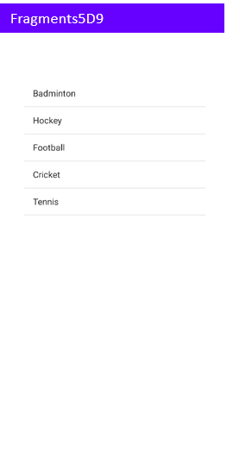 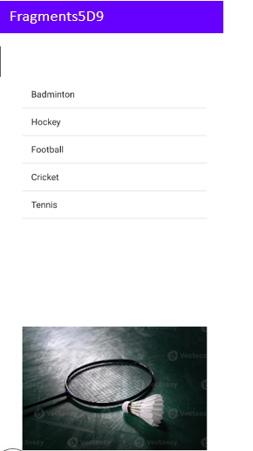 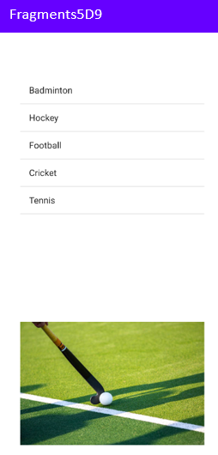

Main Activity After Clicking on Badminton After Clicking on Hockey

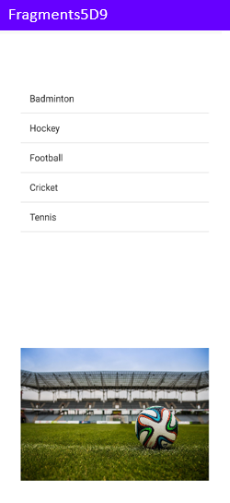 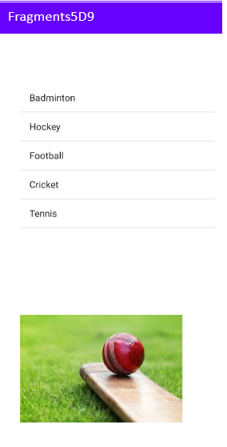

After Clicking on Football After Clicking on Cricket

**RESULT:** Mobile application based on the concept fragment built successfully.

**Experiment: 7.1 Date: 21-2-2025**

**Build mobile application serverless database SQLite Database**

**AIM:** To build mobile application serverless database SQLite Database.

**EXPERIMENTAL REQUIREMENTS:** PC with Android Studio and Internet connection

**THEORY:**

**SQLite Database**

SQLite is a lightweight **serverless** database engine integrated into Android. It allows developers to manage structured data efficiently without requiring an internet connection. The **android.database.sqlite** package provides built-in classes and methods for managing SQLite databases in Android applications.

**SQLiteOpenHelper**

* Helps in creating, upgrading, and managing the database.
* It extends the SQLiteOpenHelper class and overrides two key methods:
  + onCreate(SQLiteDatabase db): Creates tables when the database is first created.
  + onUpgrade(SQLiteDatabase db, int oldVersion, int newVersion): Updates the database structure when required.

**SQLiteDatabase**

* Provides methods to perform **CRUD operations** (Create, Read, Update, Delete) on the database.
* Common methods:
  + insert() – Adds a new record.
  + query() – Retrieves data from the database.
  + update() – Modifies existing records.
  + delete() – Removes data from the database.
  + execSQL() – Executes raw SQL commands.

**Roles of Each File**

1. **MainActivity.java**
   * Handles user input, button clicks, and interactions.
   * Calls database methods to insert, update, delete, and retrieve student records.
   * Displays data in a RecyclerView or ListView.
2. **Student.java (Model Class)**
   * Represents a Student entity with attributes like id, name, and grade.
   * Contains getter and setter methods for data handling.
3. **StudentGradeDb.java (Database Helper Class)**
   * Extends SQLiteOpenHelper to create and manage the database.
   * Implements CRUD (Create, Read, Update, Delete) methods.
   * Uses onCreate() to define the database schema.
   * Uses onUpgrade() to update the database when needed.

**PROCEDURE:**

1. Open Android Studio and create a New Project with Empty Activity.
2. Enter project name, package name, select Java or Kotlin, and click Finish.
3. In the java/com.example.app folder, create a new Java Class named Student.java.
4. Define attributes like id, name, and grade, along with getter and setter methods.
5. In the java/com.example.app folder, create another Java Class named StudentGradeDb.java.
6. Extend SQLiteOpenHelper in StudentGradeDb.java, override onCreate() to define the database schema, and implement CRUD methods (insert, update, delete, query).
7. Open MainActivity.java, design the UI in activity_main.xml with input fields and buttons for database operations.
8. In MainActivity.java, create an instance of StudentGradeDb, call database methods for adding, updating, deleting, and fetching student records.
9. Run the application on an Emulator or Physical Device and test database functionality.

**PROGRAMS:**

**MainActivity.java**

package com.example.sqlite_5d9;  
  
import android.os.Bundle;  
import android.view.View;  
import android.widget.Button;  
import android.widget.EditText;  
import android.widget.Toast;  
  
import androidx.activity.EdgeToEdge;  
import androidx.appcompat.app.AppCompatActivity;  
import androidx.core.graphics.Insets;  
import androidx.core.view.ViewCompat;  
import androidx.core.view.WindowInsetsCompat;  
  
public class MainActivity extends AppCompatActivity {  
 private EditText edtxt_roll, edtxt_name, edtxt_avg, edtxt_grade;  
 private DatabaseHelper dbHelper;  
  
 @Override  
 protected void onCreate(Bundle savedInstanceState) {  
 super.onCreate(savedInstanceState);  
 EdgeToEdge.*enable*(this);  
 setContentView(R.layout.*activity_main*);  
 ViewCompat.*setOnApplyWindowInsetsListener*(findViewById(R.id.*main*), (v, insets) -> {  
 Insets systemBars = insets.getInsets(WindowInsetsCompat.Type.*systemBars*());  
 v.setPadding(systemBars.left, systemBars.top, systemBars.right, systemBars.bottom);  
 return insets;  
 });  
  
 // Initialize UI components  
 edtxt_roll = findViewById(R.id.*edtxt_roll*);  
 edtxt_name = findViewById(R.id.*edtxt_name*);  
 edtxt_avg = findViewById(R.id.*edtxt_avg*);  
 edtxt_grade = findViewById(R.id.*edtxt_grade*);  
  
 Button btnInsert = findViewById(R.id.*btn_insert*);  
 Button btnGet = findViewById(R.id.*btn_get*);  
 Button btnUpdate = findViewById(R.id.*btn_update*);  
 Button btnDelete = findViewById(R.id.*btn_delete*);  
  
 // Initialize SQLite helper  
 dbHelper = new DatabaseHelper(this);  
  
 // Set button click listeners  
 btnInsert.setOnClickListener(v -> insertStudent());  
 btnGet.setOnClickListener(v -> getStudent());  
 btnUpdate.setOnClickListener(v -> updateStudent());  
 btnDelete.setOnClickListener(v -> deleteStudent());  
 }  
  
 private void insertStudent() {  
 String roll = edtxt_roll.getText().toString().trim();  
 String name = edtxt_name.getText().toString().trim();  
 String avg = edtxt_avg.getText().toString().trim();  
 String grade = edtxt_grade.getText().toString().trim();  
  
 if (roll.isEmpty() || name.isEmpty() || avg.isEmpty() || grade.isEmpty()) {  
 Toast.*makeText*(this, "Please fill all fields", Toast.*LENGTH_SHORT*).show();  
 return;  
 }  
  
 Student student = new Student(roll, name, avg, grade);  
 if (dbHelper.insertStudent(student)) {  
 Toast.*makeText*(this, "Student Inserted", Toast.*LENGTH_SHORT*).show();  
 clearFields();  
 } else {  
 Toast.*makeText*(this, "Insertion Failed", Toast.*LENGTH_SHORT*).show();  
 }  
 }  
  
 private void getStudent() {  
 String roll = edtxt_roll.getText().toString().trim();  
 if (roll.isEmpty()) {  
 Toast.*makeText*(this, "Please enter roll number", Toast.*LENGTH_SHORT*).show();  
 return;  
 }  
  
 Student student = dbHelper.getStudent(roll);  
 if (student != null) {  
 edtxt_name.setText(student.getName());  
 edtxt_avg.setText(student.getAvg());  
 edtxt_grade.setText(student.getGrade());  
 Toast.*makeText*(this, "Student Found: " + student.getName(), Toast.*LENGTH_SHORT*).show();  
 } else {  
 Toast.*makeText*(this, "No student found with roll: " + roll, Toast.*LENGTH_SHORT*).show();  
 }  
 }  
  
 private void updateStudent() {  
 String roll = edtxt_roll.getText().toString().trim();  
 String name = edtxt_name.getText().toString().trim();  
 String avg = edtxt_avg.getText().toString().trim();  
 String grade = edtxt_grade.getText().toString().trim();  
  
 if (roll.isEmpty() || name.isEmpty() || avg.isEmpty() || grade.isEmpty()) {  
 Toast.*makeText*(this, "Please fill all fields", Toast.*LENGTH_SHORT*).show();  
 return;  
 }  
  
 Student student = new Student(roll, name, avg, grade);  
 if (dbHelper.updateStudent(student)) {  
 Toast.*makeText*(this, "Student Updated", Toast.*LENGTH_SHORT*).show();  
 clearFields();  
 } else {  
 Toast.*makeText*(this, "Update Failed", Toast.*LENGTH_SHORT*).show();  
 }  
 }  
  
 private void deleteStudent() {  
 String roll = edtxt_roll.getText().toString().trim();  
 if (roll.isEmpty()) {  
 Toast.*makeText*(this, "Please enter roll number", Toast.*LENGTH_SHORT*).show();  
 return;  
 }  
  
 if (dbHelper.deleteStudent(roll)) {  
 Toast.*makeText*(this, "Student Deleted", Toast.*LENGTH_SHORT*).show();  
 clearFields();  
 } else {  
 Toast.*makeText*(this, "Deletion Failed", Toast.*LENGTH_SHORT*).show();  
 }  
 }  
  
 private void clearFields() {  
 edtxt_roll.setText("");  
 edtxt_name.setText("");  
 edtxt_avg.setText("");  
 edtxt_grade.setText("");  
 }  
}

**Student.java**

package com.example.sqlite_5d9;  
public class Student {  
 private String roll;  
 private String name;  
 private String avg;  
 private String grade;  
  
 public Student(String roll, String name, String avg, String grade) {  
 this.roll = roll;  
 this.name = name;  
 this.avg = avg;  
 this.grade = grade;  
 }  
  
 // Getters and Setters  
 public String getRoll() { return roll; }  
 public void setRoll(String roll) { this.roll = roll; }  
 public String getName() { return name; }  
 public void setName(String name) { this.name = name; }  
 public String getAvg() { return avg; }  
 public void setAvg(String avg) { this.avg = avg; }  
 public String getGrade() { return grade; }  
 public void setGrade(String grade) { this.grade = grade; }  
}

**DatabaseHelper.java**

package com.example.sqlite_5d9;  
  
import android.content.ContentValues;  
import android.content.Context;  
import android.database.Cursor;  
import android.database.sqlite.SQLiteDatabase;  
import android.database.sqlite.SQLiteOpenHelper;  
  
public class DatabaseHelper extends SQLiteOpenHelper {  
 private static final String *DATABASE_NAME* = "StudentDB";  
 private static final int *DATABASE_VERSION* = 1;  
 private static final String *TABLE_NAME* = "students";  
 private static final String *COL_ROLL* = "roll";  
 private static final String *COL_NAME* = "name";  
 private static final String *COL_AVG* = "avg";  
 private static final String *COL_GRADE* = "grade";  
  
 public DatabaseHelper(Context context) {  
 super(context, *DATABASE_NAME*, null, *DATABASE_VERSION*);  
 }  
  
 @Override  
 public void onCreate(SQLiteDatabase db) {  
 String CREATE_TABLE = "CREATE TABLE " + *TABLE_NAME* + " (" +  
 *COL_ROLL* + " TEXT PRIMARY KEY, " +  
 *COL_NAME* + " TEXT, " +  
 *COL_AVG* + " TEXT, " +  
 *COL_GRADE* + " TEXT)";  
 db.execSQL(CREATE_TABLE);  
 }  
  
 @Override  
 public void onUpgrade(SQLiteDatabase db, int oldVersion, int newVersion) {  
 db.execSQL("DROP TABLE IF EXISTS " + *TABLE_NAME*);  
 onCreate(db);  
 }  
  
 // Insert a student  
 public boolean insertStudent(Student student) {  
 SQLiteDatabase db = this.getWritableDatabase();  
 ContentValues values = new ContentValues();  
 values.put(*COL_ROLL*, student.getRoll());  
 values.put(*COL_NAME*, student.getName());  
 values.put(*COL_AVG*, student.getAvg());  
 values.put(*COL_GRADE*, student.getGrade());  
 long result = db.insert(*TABLE_NAME*, null, values);  
 db.close();  
 return result != -1; // Return true if insert successful  
 }  
  
 // Get a student by roll number  
 public Student getStudent(String roll) {  
 SQLiteDatabase db = this.getReadableDatabase();  
 Cursor cursor = db.query(*TABLE_NAME*,  
 new String[]{*COL_ROLL*, *COL_NAME*, *COL_AVG*, *COL_GRADE*},  
 *COL_ROLL* + "=?",  
 new String[]{roll}, null, null, null);  
  
 if (cursor != null && cursor.moveToFirst()) {  
 Student student = new Student(  
 cursor.getString(0), // roll  
 cursor.getString(1), // name  
 cursor.getString(2), // avg  
 cursor.getString(3) // grade  
 );  
 cursor.close();  
 return student;  
 }  
 if (cursor != null) cursor.close();  
 return null;  
 }  
  
 // Update a student  
 public boolean updateStudent(Student student) {  
 SQLiteDatabase db = this.getWritableDatabase();  
 ContentValues values = new ContentValues();  
 values.put(*COL_NAME*, student.getName());  
 values.put(*COL_AVG*, student.getAvg());  
 values.put(*COL_GRADE*, student.getGrade());  
 int result = db.update(*TABLE_NAME*, values, *COL_ROLL* + "=?",  
 new String[]{student.getRoll()});  
 db.close();  
 return result > 0; // Return true if update successful  
 }  
  
 // Delete a student  
 public boolean deleteStudent(String roll) {  
 SQLiteDatabase db = this.getWritableDatabase();  
 int result = db.delete(*TABLE_NAME*, *COL_ROLL* + "=?",  
 new String[]{roll});  
 db.close();  
 return result > 0; // Return true if delete successful  
 }  
}

**activity_main.xml**

<?xml version="1.0" encoding="utf-8"?>  
<LinearLayout xmlns:android="http://schemas.android.com/apk/res/android"  
 android:id="@+id/main"  
 android:layout_width="match_parent"  
 android:layout_height="match_parent"  
 android:orientation="vertical"  
 android:padding="16dp">  
  
 <TextView  
 android:layout_width="match_parent"  
 android:layout_height="wrap_content"  
 android:text="Student Details (SQLite)"  
 android:textAlignment="center"  
 android:textSize="24sp"  
 android:textStyle="bold"  
 android:layout_marginBottom="20dp"/>  
  
 <EditText  
 android:id="@+id/edtxt_roll"  
 android:layout_width="match_parent"  
 android:layout_height="48dp"  
 android:hint="Enter Roll Number"  
 android:textSize="18sp"  
 android:padding="10dp"  
 android:inputType="text"  
 android:layout_marginBottom="15dp"/>  
  
 <EditText  
 android:id="@+id/edtxt_name"  
 android:layout_width="match_parent"  
 android:layout_height="48dp"  
 android:hint="Enter Name"  
 android:textSize="18sp"  
 android:padding="10dp"  
 android:inputType="text"  
 android:layout_marginBottom="15dp"/>  
  
 <EditText  
 android:id="@+id/edtxt_avg"  
 android:layout_width="match_parent"  
 android:layout_height="48dp"  
 android:hint="Enter Average"  
 android:textSize="18sp"  
 android:padding="10dp"  
 android:inputType="numberDecimal"  
 android:layout_marginBottom="15dp"/>  
  
 <EditText  
 android:id="@+id/edtxt_grade"  
 android:layout_width="match_parent"  
 android:layout_height="48dp"  
 android:hint="Enter Grade"  
 android:textSize="18sp"  
 android:padding="10dp"  
 android:inputType="text"  
 android:layout_marginBottom="15dp"/>  
  
 <!-- First row: Insert and Get -->  
 <LinearLayout  
 android:layout_width="match_parent"  
 android:layout_height="wrap_content"  
 android:orientation="horizontal"  
 android:gravity="center"  
 android:layout_marginTop="20dp">  
  
 <Button  
 android:id="@+id/btn_insert"  
 android:layout_width="0dp"  
 android:layout_height="wrap_content"  
 android:layout_weight="1"  
 android:minHeight="48dp"  
 android:padding="12dp"  
 android:text="Insert"  
 android:layout_marginEnd="8dp"/>  
  
 <Button  
 android:id="@+id/btn_get"  
 android:layout_width="0dp"  
 android:layout_height="wrap_content"  
 android:layout_weight="1"  
 android:minHeight="48dp"  
 android:padding="12dp"  
 android:text="Get"  
 android:layout_marginStart="8dp"/>  
  
 </LinearLayout>  
  
 <!-- Second row: Update and Delete -->  
 <LinearLayout  
 android:layout_width="match_parent"  
 android:layout_height="wrap_content"  
 android:orientation="horizontal"  
 android:gravity="center"  
 android:layout_marginTop="15dp">  
  
 <Button  
 android:id="@+id/btn_update"  
 android:layout_width="0dp"  
 android:layout_height="wrap_content"  
 android:layout_weight="1"  
 android:minHeight="48dp"  
 android:padding="12dp"  
 android:text="Update"  
 android:layout_marginEnd="8dp"/>  
  
 <Button  
 android:id="@+id/btn_delete"  
 android:layout_width="0dp"  
 android:layout_height="wrap_content"  
 android:layout_weight="1"  
 android:minHeight="48dp"  
 android:padding="12dp"  
 android:text="Delete"  
 android:layout_marginStart="8dp"/>  
  
 </LinearLayout>  
</LinearLayout>

**OUTPUT:**

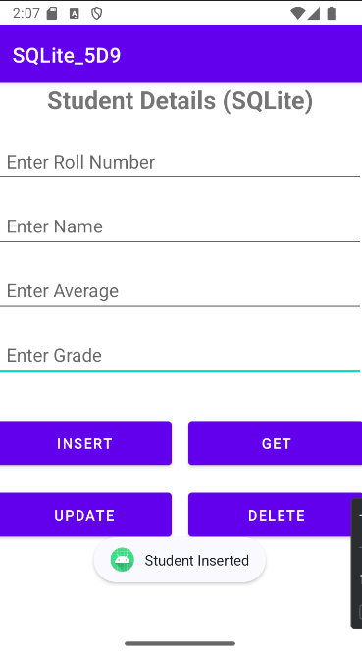 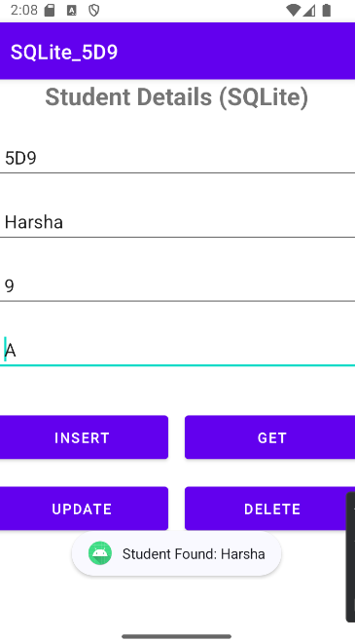 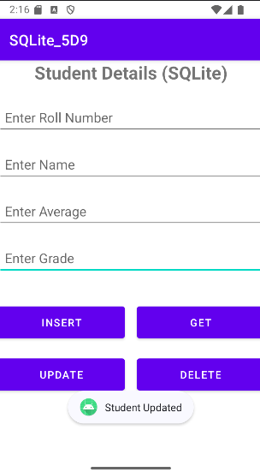

Insert operation Select operation Update operation

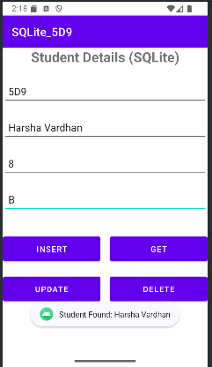 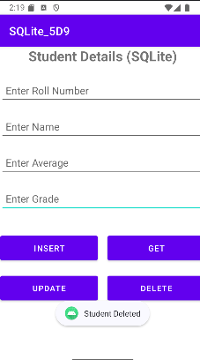

Select after updation Deletion operation

Database After Insertion:

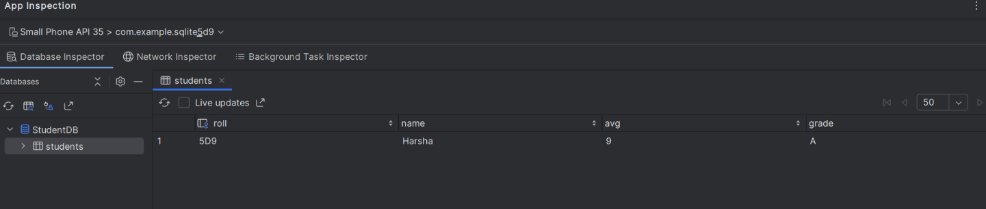

Database After Updation:

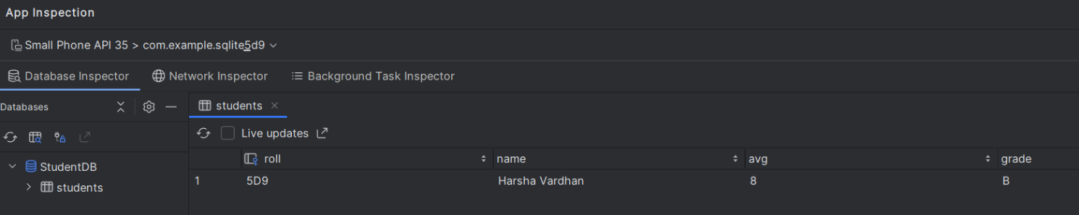

Database After Deletion: 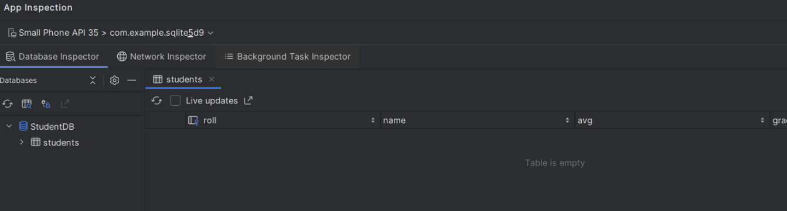

**RESULT:** Mobile application with serverless SQLite Database is built successfully.

**Experiment: 7.2 Date: 28-02-2025**

**Build mobile application cloud based database Firebase**

**Firebase**

Firebase is a Backend-as-a-Service (BaaS) platform developed by Google that provides tools and infrastructure to build web and mobile applications. It offers services such as database management, authentication, cloud storage, and real-time data synchronization without the need for managing backend servers.

**Firebase Realtime Database**

* A cloud-hosted NoSQL database that allows real-time data synchronization.
* Stores data in JSON format and updates automatically across connected clients.
* Works offline, syncing changes when the device reconnects to the internet.

**PROCEDURE:**

**Steps to Connect Firebase Using Firebase Assistant in Android Studio**

1. Create a New Android Project in Android Studio (Empty Activity, Java/Kotlin, API 21+).
2. Open Firebase Assistant: Click Tools → Firebase in Android Studio.
3. Connect to Firebase:
   1. In Firebase Assistant, go to Realtime Database → Set up Firebase Realtime Database → Connect to Firebase.
   2. This opens the Firebase Console in your browser.
4. Create a Firebase Project:
   1. Click Create a Project.
   2. Enter a Project Name
   3. Click Continue, then enable Google Analytics (optional).
   4. Click Create Project and wait for it to complete.

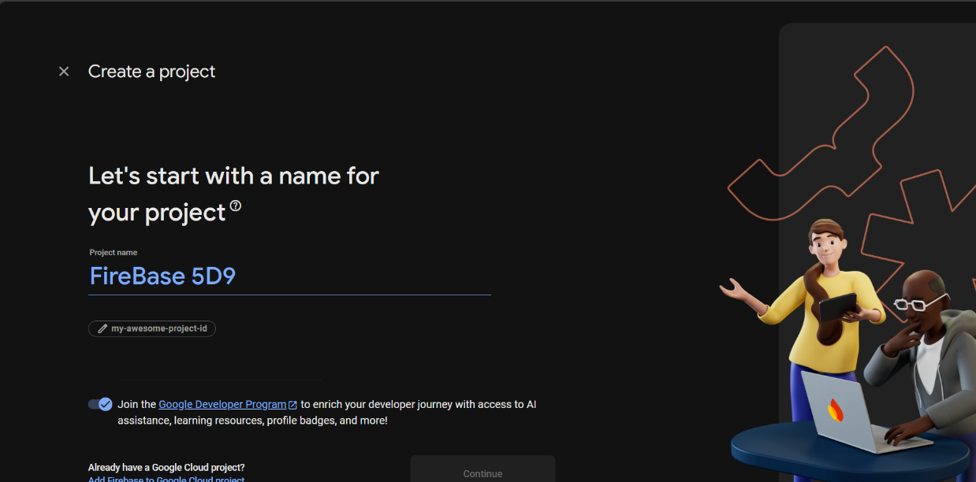

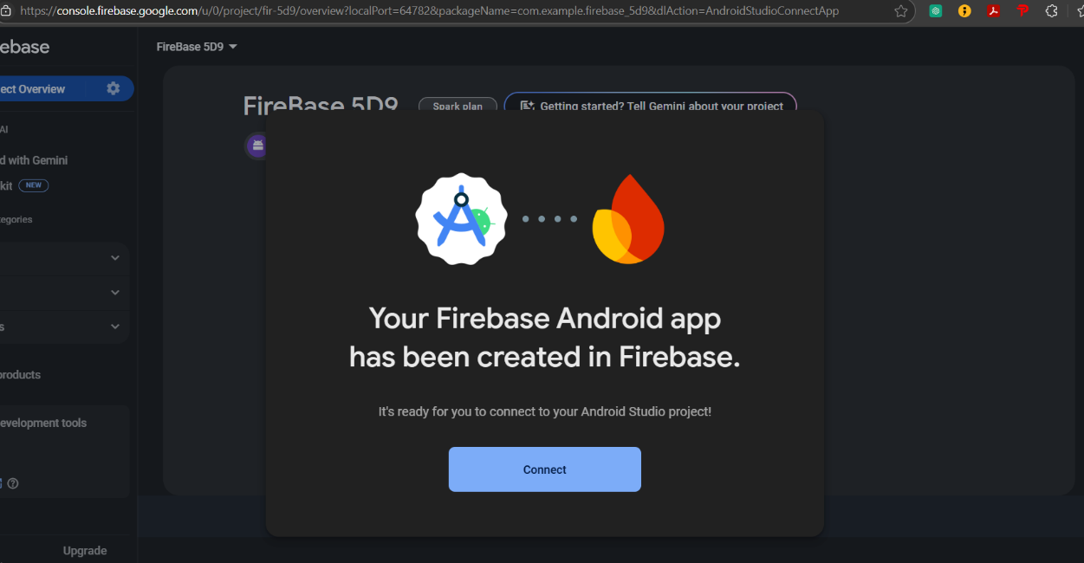

1. Add Firebase SDK:
   1. Go back to Android Studio and click "Add Realtime Database to Your App".
   2. Android Studio will automatically add Firebase dependencies in Gradle files.
   3. Click Sync Now to apply changes.

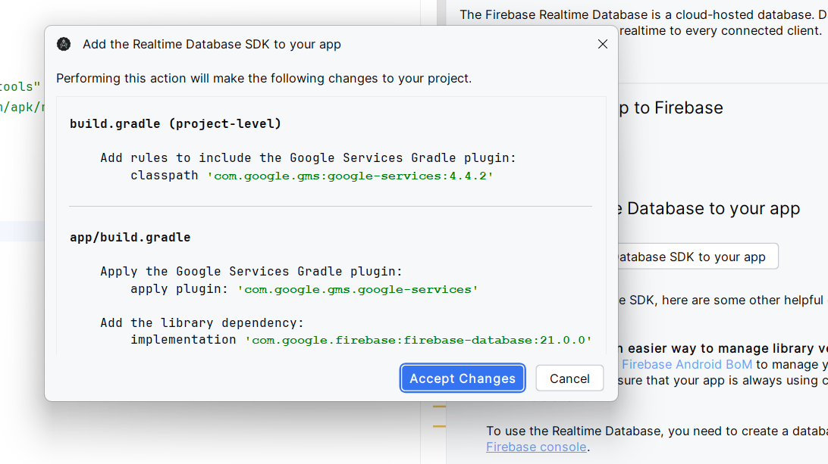

1. Enable Realtime Database:
   1. Open Firebase Console → Realtime Database.
   2. Click Create Database.
   3. Choose Database Location (e.g., us-central1, asia-south1).
   4. Select Start in Test Mode (for development, allows unrestricted read/write access).
   5. Click Enable

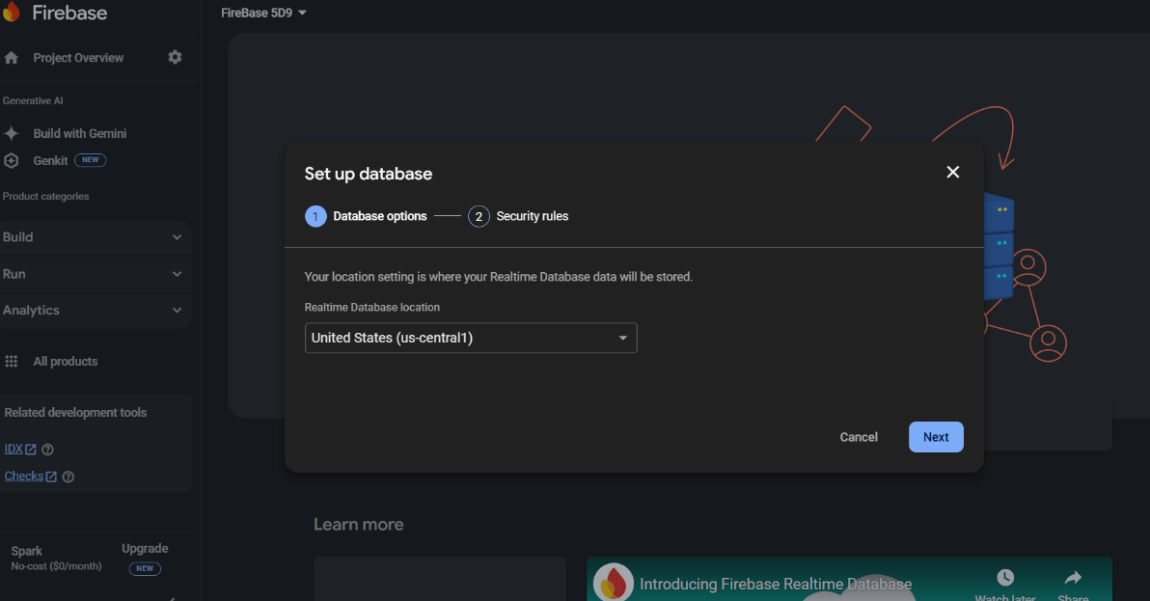

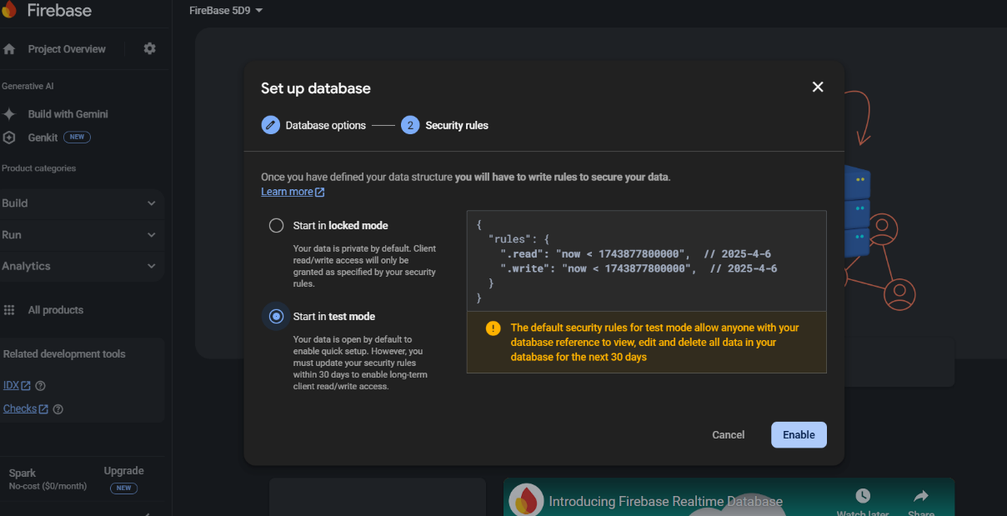

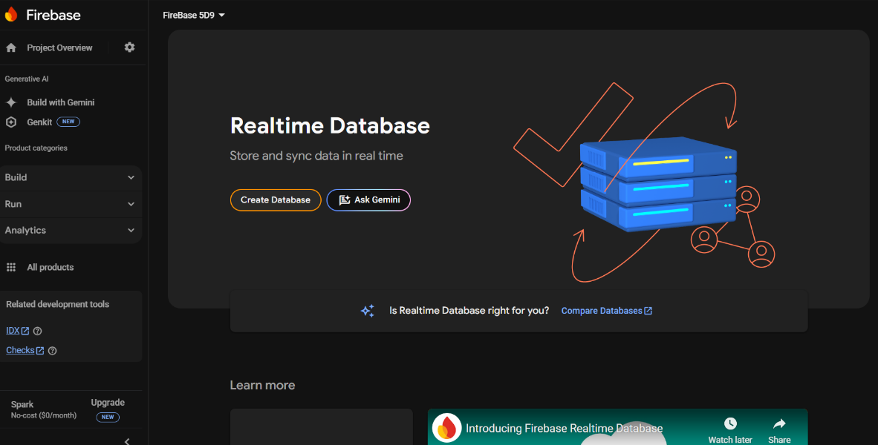

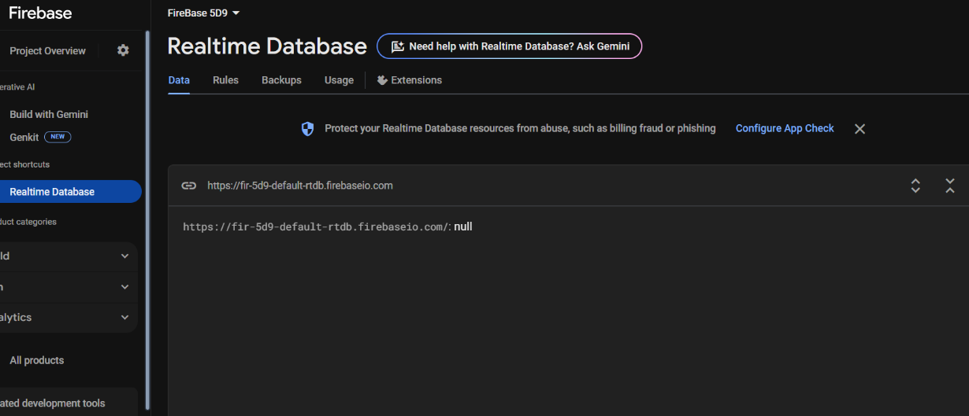

**PROGRAMS:**

**MainActivity.java**

package com.example.firebase_5d9;  
  
import android.os.Bundle;  
import android.view.View;  
import android.widget.EditText;  
import android.widget.Toast;  
  
import androidx.activity.EdgeToEdge;  
import androidx.appcompat.app.AppCompatActivity;  
import androidx.core.graphics.Insets;  
import androidx.core.view.ViewCompat;  
import androidx.core.view.WindowInsetsCompat;  
  
import com.google.android.gms.tasks.OnFailureListener;  
import com.google.android.gms.tasks.OnSuccessListener;  
import com.google.firebase.database.DataSnapshot;  
import com.google.firebase.database.DatabaseReference;  
import com.google.firebase.database.FirebaseDatabase;  
  
public class MainActivity extends AppCompatActivity {  
 EditText edtxt_roll, edtxt_name, edtxt_avg, edtxt_grade;  
 FirebaseDatabase fdb;  
 DatabaseReference studentRef; // Added DatabaseReference for better structure  
  
 @Override  
 protected void onCreate(Bundle savedInstanceState) {  
 super.onCreate(savedInstanceState);  
 EdgeToEdge.*enable*(this);  
 setContentView(R.layout.*activity_main*);  
 ViewCompat.*setOnApplyWindowInsetsListener*(findViewById(R.id.*main*), (v, insets) -> {  
 Insets systemBars = insets.getInsets(WindowInsetsCompat.Type.*systemBars*());  
 v.setPadding(systemBars.left, systemBars.top, systemBars.right, systemBars.bottom);  
 return insets;  
 });  
  
 edtxt_roll = findViewById(R.id.*edtxt_roll*);  
 edtxt_name = findViewById(R.id.*edtxt_name*);  
 edtxt_avg = findViewById(R.id.*edtxt_avg*);  
 edtxt_grade = findViewById(R.id.*edtxt_grade*);  
  
 fdb = FirebaseDatabase.*getInstance*();  
 studentRef = fdb.getReference("students"); // Changed to plural "students" for better naming  
 }  
  
 public void insertStudent(View v) {  
 String roll = edtxt_roll.getText().toString();  
 Student s = new Student(roll, edtxt_name.getText().toString(),  
 edtxt_avg.getText().toString(),  
 edtxt_grade.getText().toString());  
  
 studentRef.child(roll).setValue(s)  
 .addOnSuccessListener(unused ->  
 Toast.*makeText*(MainActivity.this, "Insertion Successful", Toast.*LENGTH_LONG*).show())  
 .addOnFailureListener(e ->  
 Toast.*makeText*(MainActivity.this, "Insertion Failure: " + e.getMessage(), Toast.*LENGTH_LONG*).show());  
 }  
  
 // Added CRUD operations  
 public void getStudent(View v) {  
 String roll = edtxt_roll.getText().toString();  
 studentRef.child(roll).get()  
 .addOnSuccessListener(dataSnapshot -> {  
 if (dataSnapshot.exists()) {  
 Student s = dataSnapshot.getValue(Student.class);  
 if (s != null) {  
 edtxt_name.setText(s.getName());  
 edtxt_avg.setText(s.getAvg());  
 edtxt_grade.setText(s.getGrade());  
 Toast.*makeText*(MainActivity.this, "Student Found: " + s.getName(), Toast.*LENGTH_LONG*).show();  
 }  
 } else {  
 Toast.*makeText*(MainActivity.this, "No student found with Roll No: " + roll, Toast.*LENGTH_LONG*).show();  
 }  
 })  
 .addOnFailureListener(e ->  
 Toast.*makeText*(MainActivity.this, "Retrieval Failure: " + e.getMessage(), Toast.*LENGTH_LONG*).show());  
 }  
  
 public void updateStudent(View v) {  
 String roll = edtxt_roll.getText().toString();  
 Student s = new Student(roll, edtxt_name.getText().toString(),  
 edtxt_avg.getText().toString(),  
 edtxt_grade.getText().toString());  
  
 studentRef.child(roll).setValue(s)  
 .addOnSuccessListener(unused ->  
 Toast.*makeText*(MainActivity.this, "Update Successful", Toast.*LENGTH_LONG*).show())  
 .addOnFailureListener(e ->  
 Toast.*makeText*(MainActivity.this, "Update Failure: " + e.getMessage(), Toast.*LENGTH_LONG*).show());  
 }  
  
 public void deleteStudent(View v) {  
 String roll = edtxt_roll.getText().toString();  
 studentRef.child(roll).removeValue()  
 .addOnSuccessListener(unused ->  
 Toast.*makeText*(MainActivity.this, "Deletion Successful", Toast.*LENGTH_LONG*).show())  
 .addOnFailureListener(e ->  
 Toast.*makeText*(MainActivity.this, "Deletion Failure: " + e.getMessage(), Toast.*LENGTH_LONG*).show());  
 }  
}

**student.java**

package com.example.firebase_5d9;  
  
public class Student {  
 private String roll, name, avg, grade;  
  
 // Added default constructor required by Firebase  
 public Student() {}  
  
 public Student(String roll, String name, String avg, String grade) {  
 this.roll = roll;  
 this.name = name;  
 this.avg = avg;  
 this.grade = grade;  
 }  
  
 public String getRoll() { return roll; }  
 public String getName() { return name; }  
 public String getAvg() { return avg; }  
 public String getGrade() { return grade; }  
  
 // Added setters for updating  
 public void setRoll(String roll) { this.roll = roll; }  
 public void setName(String name) { this.name = name; }  
 public void setAvg(String avg) { this.avg = avg; }  
 public void setGrade(String grade) { this.grade = grade; }  
}

**activity_main.xml**

<?xml version="1.0" encoding="utf-8"?>  
<LinearLayout xmlns:android="http://schemas.android.com/apk/res/android"  
 xmlns:tools="http://schemas.android.com/tools"  
 android:id="@+id/main"  
 android:layout_width="match_parent"  
 android:layout_height="match_parent"  
 android:orientation="vertical"  
 tools:context=".MainActivity"  
 android:padding="16dp">  
  
 <TextView  
 android:layout_width="match_parent"  
 android:layout_height="wrap_content"  
 android:text="Student Details"  
 android:textAlignment="center"  
 android:textSize="24sp"  
 android:textStyle="bold"  
 android:layout_marginBottom="20dp"/>  
  
 <EditText  
 android:id="@+id/edtxt_roll"  
 android:layout_width="match_parent"  
 android:layout_height="48dp"  
 android:hint="Enter Roll Number"  
 android:textSize="18sp"  
 android:padding="10dp"  
 android:layout_marginBottom="15dp"/>  
  
 <EditText  
 android:id="@+id/edtxt_name"  
 android:layout_width="match_parent"  
 android:layout_height="48dp"  
 android:hint="Enter Name"  
 android:textSize="18sp"  
 android:padding="10dp"  
 android:layout_marginBottom="15dp"/>  
  
 <EditText  
 android:id="@+id/edtxt_avg"  
 android:layout_width="match_parent"  
 android:layout_height="48dp"  
 android:hint="Enter Average"  
 android:textSize="18sp"  
 android:padding="10dp"  
 android:layout_marginBottom="15dp"/>  
  
 <EditText  
 android:id="@+id/edtxt_grade"  
 android:layout_width="match_parent"  
 android:layout_height="48dp"  
 android:hint="Enter Grade"  
 android:textSize="18sp"  
 android:padding="10dp"  
 android:layout_marginBottom="15dp"/>  
  
 <!-- First row of buttons: Insert and Get -->  
 <LinearLayout  
 android:layout_width="match_parent"  
 android:layout_height="wrap_content"  
 android:orientation="horizontal"  
 android:gravity="center"  
 android:layout_marginTop="20dp">  
  
 <Button  
 android:layout_width="0dp"  
 android:layout_height="wrap_content"  
 android:layout_weight="1"  
 android:minHeight="48dp"  
 android:onClick="insertStudent"  
 android:padding="12dp"  
 android:text="Insert"  
 android:layout_marginEnd="8dp"/>  
  
 <Button  
 android:layout_width="0dp"  
 android:layout_height="wrap_content"  
 android:layout_weight="1"  
 android:minHeight="48dp"  
 android:onClick="getStudent"  
 android:padding="12dp"  
 android:text="Get"  
 android:layout_marginStart="8dp"/>  
  
 </LinearLayout>  
  
 <!-- Second row of buttons: Update and Delete -->  
 <LinearLayout  
 android:layout_width="match_parent"  
 android:layout_height="wrap_content"  
 android:orientation="horizontal"  
 android:gravity="center"  
 android:layout_marginTop="15dp">  
  
 <Button  
 android:layout_width="0dp"  
 android:layout_height="wrap_content"  
 android:layout_weight="1"  
 android:minHeight="48dp"  
 android:onClick="updateStudent"  
 android:padding="12dp"  
 android:text="Update"  
 android:layout_marginEnd="8dp"/>  
  
 <Button  
 android:layout_width="0dp"  
 android:layout_height="wrap_content"  
 android:layout_weight="1"  
 android:minHeight="48dp"  
 android:onClick="deleteStudent"  
 android:padding="12dp"  
 android:text="Delete"  
 android:layout_marginStart="8dp"/>  
  
 </LinearLayout>  
</LinearLayout>

**OUTPUT:**

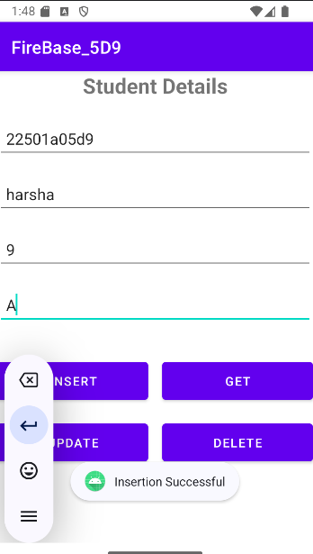 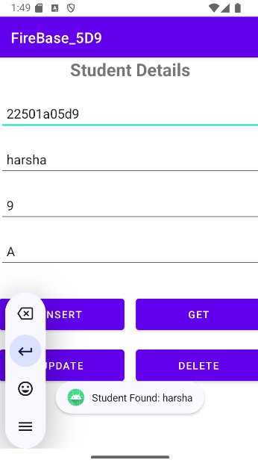 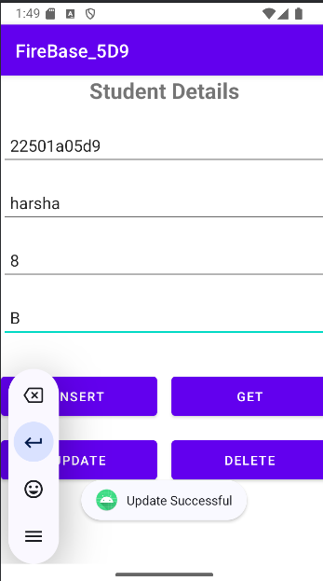

Insert operation Select operation Update operation

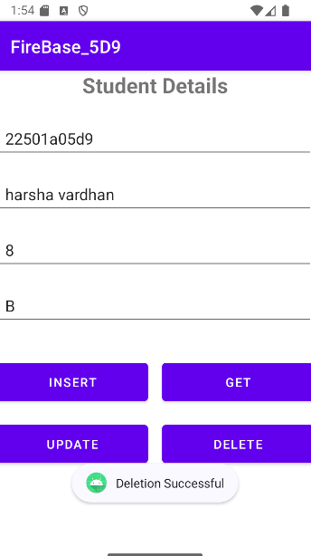

Deletion operation

In FireBase

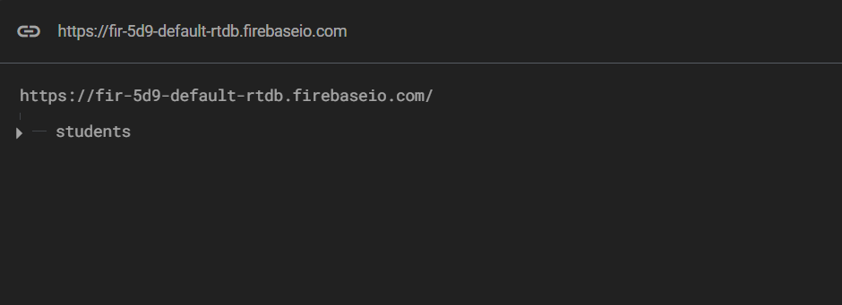

Students:

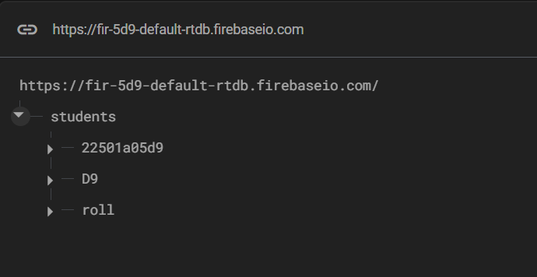

Database After Insertion:

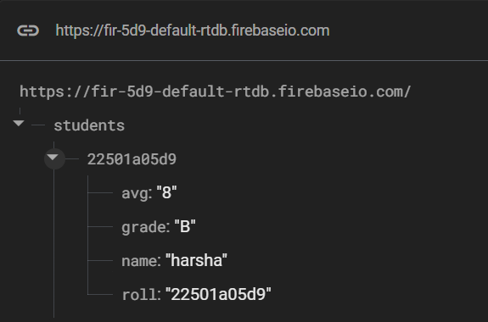

Database After Updation:

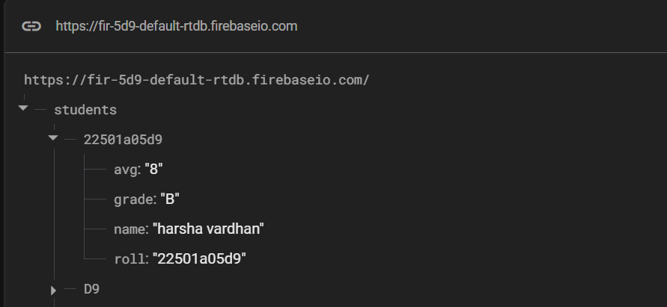

Database After Deletion:

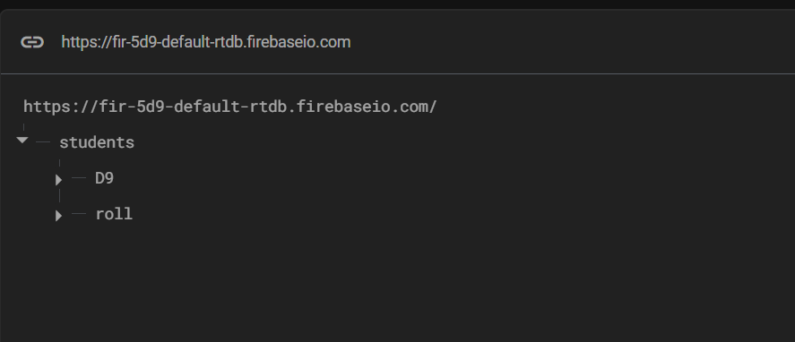

**RESULT:** Mobile application with cloud based Firebase is built successfully.

**Experiment: 8 Date: 21-3-2025**

**Build mobile application based on the Google Maps.**

**AIM:** To build mobile application based on the google maps.

**EXPERIMENTAL REQUIREMENTS:** PC with Android Studio and Internet connection

**THEORY:**

Google Maps is a widely used service that provides mapping and location-based functionalities. Developers can integrate Google Maps into mobile applications using the Google Maps API. This theory explains the fundamental concepts behind Google Maps API integration, including its purpose, benefits, and significance in mobile application development.

Google Maps API is a set of web services that allows developers to incorporate mapping features into applications. It enables functionalities such as location search, real-time navigation, traffic updates, and user location tracking. By utilizing Google Maps API, developers can enhance their applications with geographic and location-based features.

To integrate Google Maps into a mobile application, developers must obtain an API key, configure it within the application, and use relevant SDKs or libraries provided by Google. The integration process involves embedding a map view, customizing map features, and implementing additional functionalities such as markers, route planning, and geolocation tracking.

**PROCEDURE:**

1. Open Android Studio and click on "New Project" in the Welcome screen. Select "No Activity" under the "Phone and Tablet" category and click "Next."
2. Enter the project details, set the language to Java, and select a Minimum SDK version of API Level 21 or higher. Click "Finish" and wait for Gradle to build the project.
3. Open Google Cloud Console and create a new project.

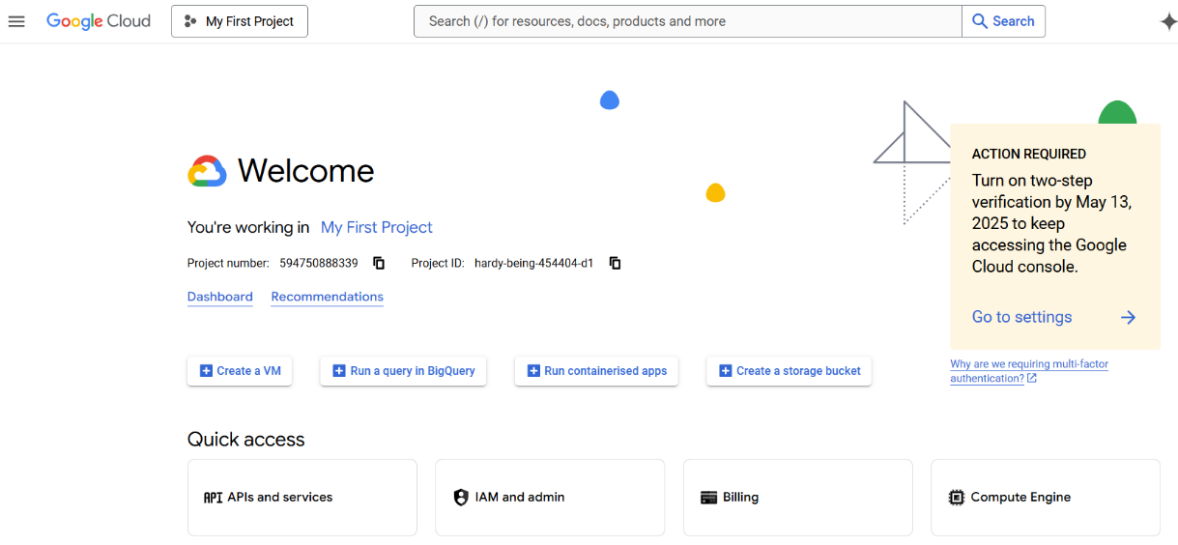

1. Navigate to "APIs & Services," enable "Google Maps SDK for Android," and go to the "Credentials" section. Click "Create Credentials" and select "API Key." Restrict the API key for security and copy it for later use.

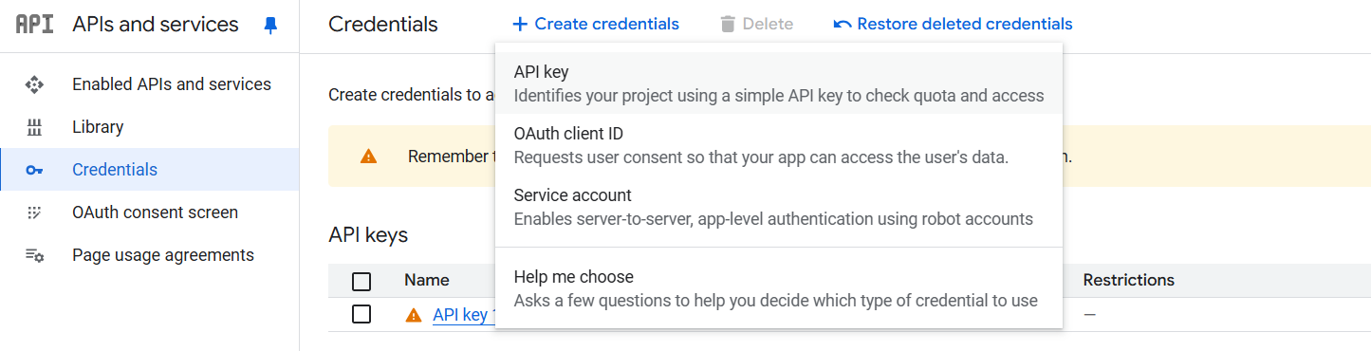

1. In Android Studio, right-click the "app" folder, go to "New," select "Google," and then choose "Google Maps Views Activity." Check the "Launcher Activity" option and click "Finish."

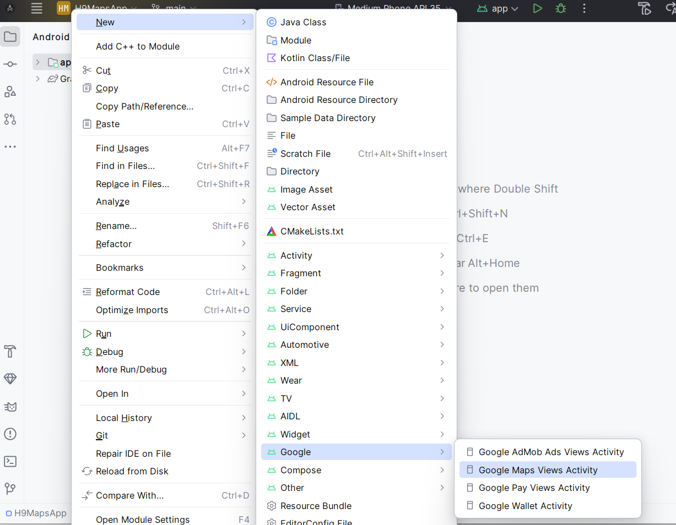

1. In the file local.properties of the project. Add the API key in the file as MAPS_API_KEY=YOUR_API_KEY.
2. Open the AndroidManifest.xml file and locate or add the <meta-data> tag inside the <application> tag. Set android:value to ${MAPS_API_KEY} to securely reference the API key.
3. Open the module-level build.gradle file and ensure that the Google Maps SDK dependency is added as implementation("com.google.android.gms:play-services-maps:19.0.0").
4. Sync the Gradle files and run the application on an emulator or a physical device to verify that the Google Map is displayed correctly.

**PROGRAMS:**

**MapsActivity.java**

package com.example.a22501a05g7_exp8;  
import androidx.fragment.app.FragmentActivity;  
import android.os.Bundle;  
import com.google.android.gms.maps.CameraUpdateFactory;  
import com.google.android.gms.maps.GoogleMap;  
import com.google.android.gms.maps.OnMapReadyCallback;  
import com.google.android.gms.maps.SupportMapFragment;  
import com.google.android.gms.maps.model.LatLng;  
import com.google.android.gms.maps.model.MarkerOptions;  
import com.example.a22501a05g7_exp8.databinding.ActivityMapsBinding;  
public class MapsActivity extends FragmentActivity implements OnMapReadyCallback {  
  
 private GoogleMap mMap;  
 private ActivityMapsBinding binding;  
 @Override  
 protected void onCreate(Bundle savedInstanceState) {  
 super.onCreate(savedInstanceState);  
  
 binding = ActivityMapsBinding.*inflate*(getLayoutInflater());  
 setContentView(binding.getRoot());  
  
 *// Obtain the SupportMapFragment and get notified when the map is ready to be used.* SupportMapFragment mapFragment = (SupportMapFragment) getSupportFragmentManager()  
 .findFragmentById(R.id.*map*);  
 mapFragment.getMapAsync(this);  
 }  
  
 */**  
 * Manipulates the map once available.  
 * This callback is triggered when the map is ready to be used.  
 * This is where we can add markers or lines, add listeners or move the camera. In this case,  
 * we just add a marker near Sydney, Australia.  
 * If Google Play services is not installed on the device, the user will be prompted to install  
 * it inside the SupportMapFragment. This method will only be triggered once the user has  
 * installed Google Play services and returned to the app.  
 */* @Override  
 public void onMapReady(GoogleMap googleMap) {  
 mMap = googleMap;  
 mMap.getUiSettings().setZoomControlsEnabled(true);  
  
 *// Add a marker in Sydney and move the camera* LatLng pvp = new LatLng(16.487780, 80.693798);  
 MarkerOptions mo=new MarkerOptions();  
 mo.position(pvp);  
 mo.title("PVPSIT COLLEGE");  
 mMap.addMarker(mo);  
  
 mMap.addMarker(new MarkerOptions().position(pvp).title("PVPSIT COLLEGE"));  
 mMap.moveCamera(CameraUpdateFactory.*newLatLng*(pvp));  
 mMap.moveCamera(CameraUpdateFactory.*newLatLng*(pvp));  
 mMap.moveCamera(CameraUpdateFactory.*zoomTo*(17));  
  
 LatLng ion = new LatLng(16.4873, 80.6983);  
 mMap.addMarker(new MarkerOptions().position(ion).title("ION DIGITAL"));  
 mMap.moveCamera(CameraUpdateFactory.*newLatLng*(ion));  
 mMap.moveCamera(CameraUpdateFactory.*newLatLng*(ion));  
 mMap.moveCamera(CameraUpdateFactory.*zoomTo*(17));  
 }  
}

**activity_maps.xml**

<?xml version="1.0" encoding="utf-8"?>

<fragment xmlns:android="http://schemas.android.com/apk/res/android"

xmlns:map="http://schemas.android.com/apk/res-auto"

xmlns:tools="http://schemas.android.com/tools"

android:id="@+id/map"

android:name="com.google.android.gms.maps.SupportMapFragment"

android:layout_width="match_parent"

android:layout_height="match_parent"

tools:context=".MapsActivity" />

**OUTPUT:**

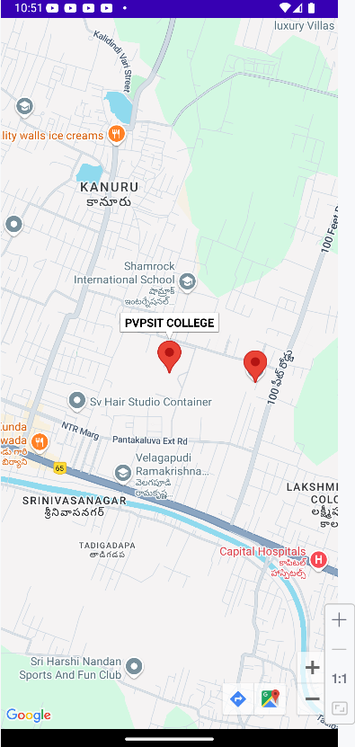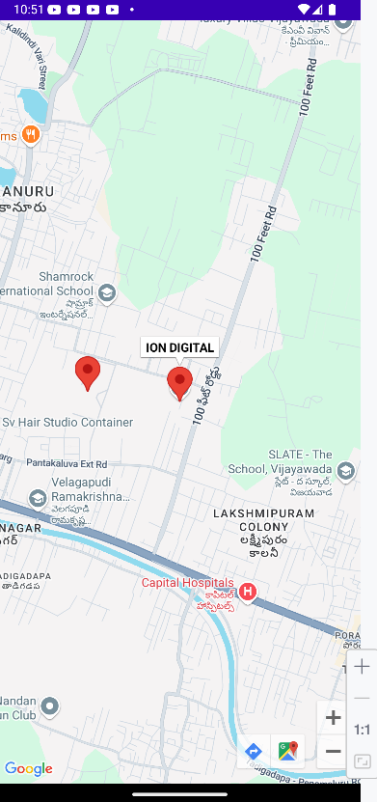

When 1st location is clicked When 2nd location is clicked

**RESULT:** Mobile application based on the Google maps built successfully.